RULES OF COMPETITION

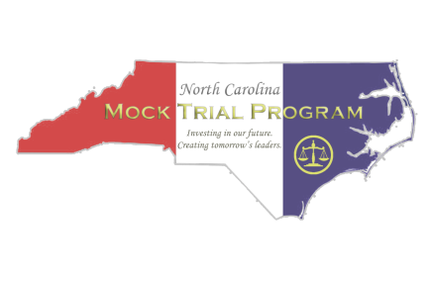

2023-2024



Table of Contents
Overview of the Competition and Message about the 2023-2024 Competition 3
Schedule for 2023-2024 4
Rules of Competition
- Program Organization and Administration 6
- Team Composition and Roles 10
- Case Materials and Restrictions 11
- Trial Procedures and Rules 12
- Judging and Team Advancement 18
- Dispute Resolution 24
- Courtroom Artist Competition 25
Rules of Evidence and Procedure 28
Regional Competition Schedule 40
Permission for Participation and Release Form 42
NCMTP Code of Ethics Form 44
M. Gordon Widenhouse, Jr. Scholarship Application 45
Bailiff/Timekeeper Duties and Script, Time Keeping Sheet and Time Cards 46
Sample Ballot 57
Trial Dispute Form 58
Steps in a Mock Trial 59
Courtroom Setting 61
Source of Proof Charts 63

NORTH CAROLINA MOCK TRIAL PROGRAM

This is our 32nd year of mock trial here in North Carolina! The program was first offered in 1992, administered by the N.C. Academy of Trial Lawyers (NCATL), and it is now managed by the Carolina Center for Civic Education (CCCE), a 501(c)(3) nonprofit created by NCATL to operate the 2005 National High School Mock Trial Championship competition in Charlotte. In 2008, NCATL changed its name to the North Carolina Advocates for Justice (NCAJ). In 2009, CCCE was tasked with the independent operation of the high school mock trial program, with the NCAJ as a major sponsor. In 2019, the CCCE changed its name to the North Carolina Mock Trial Program (NCMTP) to better reflect the mission and purpose of the organization. The NCMTP seeks to help students gain a deeper understanding and appreciation of our legal system through the hands-on activity of mock trial.

Board of Directors
Rebecca Britton President
Brooke Schmidly, Vice President
Adrienne Blocker, Treasurer
Christine Scheef, Secretary
Brad Bannon
John H. Anderson, Jr.
Drew Haywood
Jacob Morse
Brenée W. Orozco
Mark Sumwalt
David Sherlin
Sue Gray
Chris Nichols
Manisha Patel
Liz-Avery Jones
Andrew Banzhoff, Ex Officio

SCHEDULE OF EVENTS

Friday, September 8, 2023 Case Release Date
The competition case will be published online; download at http://ncmocktrial.org/.
Friday, September 29, 2023 Early Registration Registration forms submitted online or postmarked by September 29 are guaranteed assignment at one of their top choices of regions. Register your teams early to have a better chance of securing your first choice of site assignment. Schools with multiple teams: If you wish to ensure that your teams don’t compete against each other in Rounds I or II at regionals, select different site preferences for each team.
October and November 2023 Teacher/Team Training Resources A Teacher’s Resource Manual, student handouts, and many other training materials are available at http://ncmocktrial.org/resources/training-materials. In addition, a three-part teacher training video can be viewed anytime by visiting this webpage. Also, recordings of skills seminars designed to teach students about key elements of mock trial can be found at https://ncmocktrial.org/shop/ ($25/video).
Friday, December 8, 2023 *Final Registration/Team Fee Deadline* Three items are due: 1). team and courtroom artist registration; 2). signed “Notice of Withdrawal Deadlines” (an online form); and 3). fees of $325/team. Firm deadline!! Items should be received by December 8.

Thursday, January 4, 2024 *Code of Ethics, Release forms, Team Member Lists due*
- Signed team Code of Ethics form (an online form), individual signed student Releases, and Team Member list (an online form) due to the State Office. See ncmocktrial.org.

*Last Day to Withdraw without Penalty*
- If your team must withdraw, contact the Program Coordinator in writing via email no later than January 4 to request a refund of registration fees. Withdrawals at a later date will result in forfeiture of the registration fee and may incur a penalty (see Rule 1.8) due to the significant disruption caused by late withdrawals. Teams will learn their Regional Competition site assignment within 7 days of this deadline.

Thursday, February 1, 2024 *Team Rosters due*
Team rosters (fillable form at ncmocktrial.org) are due via email by Noon on

Thursday, February 1.

Saturday, February 3, 2024 Regional Competition Mock trial teams and courtroom artists compete at ten in-person regional sites throughout North Carolina (Fayetteville, Gastonia, Greenville, Hendersonville, Hickory, High Point, Hillsborough, Raleigh, Salisbury, and Wilmington). Teams at all sites will compete in two rounds of competition and will try both sides of the case. The top two teams will compete in a final round, with the winner advancing to State Finals. Courtroom artist regional winners
will be invited to compete at States.

Friday - Saturday, March 15-16, 2024 State Finals Competition The regional champions, at-large teams and courtroom artist regional winners will all meet in Raleigh to compete. On Friday, March 15, teams will arrive in Raleigh for registration, Round 1, and the Widenhouse Award reception. On Saturday, all teams will participate in two rounds of competition and the two top-ranking teams will compete in a final round. The State Champion will earn the right to represent North Carolina at the National High School Mock Trial Championship hosted by Wilmington, Delaware from May 2-5, 2024.
Rules of Competition

PROGRAM ORGANIZATION AND ADMINISTRATION

Rule 1.1. Rules
The North Carolina Mock Trial Program (“NCMTP”) Rules of Competition and the NCMTP Rules of Evidence and Procedure shall govern all trials. Questions or interpretations of these rules are within the discretion of NCMTP Executive Director and Board of Directors, whose decisions are final.

Rule 1.2. Code of Conduct; Expectations of Participants; Sanctions for Inappropriate Behavior The Rules of Competition, as well as proper rules of courthouse and courtroom decorum and security, must be followed. The ideals of fair play, civility, and friendship shall guide the conduct of all participants and observers throughout all mock trial activities, including tournament rounds, breaks between rounds, organizational meetings, and team practices. Courtesy toward opposing team members, judges, tournament officials, coaches, and one’s own team members is expected of all participants and observers.
Rule 1.2.a. Team coaches. Every team must have at least one officially designated adult team advisor/coach, who is responsible to provide adult supervision of the team, ensure that all deadlines for submission of fees and forms are met, and communicate clearly the Code of Conduct to all team members and observers. Students and/or persons who are not age 18 or older cannot serve as the designated team advisor. Because the purpose of mock trial is to instill respect for the legal system and its ideals of justice, equality, and truth, coaches are expected to champion these ideals above winning.
Rule 1.2.b. Sanctions for Inappropriate Behavior. The NCMTP possesses discretion to impose sanctions up to and including, but not limited to, deduction of points, the team’s immediate eviction from the competition, suspension from competing in future competitions, and/or forfeiture of all fees and awards (if applicable) for any misconduct, flagrant rule violation, or breaches of decorum that affect the conduct of a trial or which impugn the reputation or integrity of any team, school, participant, court officer, judge, or the mock trial program.

Rule 1.3. Registration Procedures
To participate in the NCMTP competition, teams must complete the following steps by the deadlines listed in the published schedule:

- Submit the Registration Form and Registration Fees
  - Teams that register by the Early Bird Deadline are more likely to receive their first or second choice of regional site assignments.
- Submit a signed Notice of Withdrawal Deadlines form (online)
- Submit a signed Ethics form (online)
- Submit a signed Permission/Release form for each participating student (official team members and one alternate)
- Submit a Team Member list (online)
- Submit team roster (online)
Rule 1.3.a. The Official Team Roster is “locked” when submitted on February 1. The team members may not be changed if the team advances to the next level of competition (although roles on the team may be modified as needed).

Rule 1.3.b. Any requests for roster modifications before the next level of competition (other than a change of roles) must be submitted in writing to the NCMTP Executive Director for review. The decision of the NCMTP Board regarding any such requests is final.

Rule 1.4. Regional and State Finals Competitions
The NCMTP Competition consists of two levels of team trial competitions: Regionals and State Finals. Each year, the NCMTP Board determines the total number and location of competition sites.
The NCMTP Regional Competitions (“Regionals”) are held on a Saturday in early February. The State Finals Competition (“State Finals”) is held in early March and is a two-day tournament in which every team argues each side of the case at least one time. After preliminary rounds, the top two teams shall meet in a Championship Round to determine the State Champion.

Rule 1.4.a. Use of Facilities for Regionals and State Finals. Teams are permitted and encouraged to hold a practice session in a local courthouse prior to the Regional and State Finals competitions. However, to prevent unfair advantage, teams advancing to State Finals are not to use courtroom facilities at the State Finals venues (Campbell Law School and any other State Finals sites) between the end of the regional competition and the start of the State Finals competition rounds.

Rule 1.5. Team Expenses
Expenses for the Regional and State competitions are the responsibility of the participants and their sponsoring school(s)/organization(s).
Rule 1.5.a. Nationals. The NCMTP shall pay the registration fee for the qualifying
N.C. team to participate in the National High School Mock Trial Championship competition and shall provide up to $300.00 to purchase memorabilia for the pin exchange event, if held. All other team expenses related to the National competition shall be the responsibility of the qualifying team.

Rule 1.6. Assignment of Regional Competition Site
The NCMTP reserves the right to assign each team to a regional competition site based on the following: (1) date of submission of registration form; (2) the top four sites requested by the registrant; (3) the number of teams requesting each site, with the objective of maintaining parity and an even number of teams at each site; and (4) travel time and cost considerations for the school.

Teams may have to travel up to 2 hours to their assigned regional site and should
plan accordingly. The NCMTP shall notify each school of their assigned regional competition site(s) in accordance with the published schedule for the season.
Rule 1.6.a. A school/organization may register an unlimited number of teams for the competition. However, only two teams from each school/organization may compete at the same regional competition site. If a school fielding multiple teams prefers that their teams don’t compete against each other in Rounds I or II of Regional Competition, we recommend selecting different site preferences for each team at registration. A school can register one courtroom artist per team.
Rule 1.6.b. If a school/organization has won the same regional championship for two consecutive years, its team(s) shall not be permitted to compete in that region for a third year but may compete at any of the remaining regional competition sites. The NCMTP Board reserves the right to waive this rule if circumstances warrant waiver in the discretion of the NCMTP Board.

Rule 1.6.c. A region hosting an odd number of teams must hold a bye round. If an odd number of teams is confirmed at a regional site, the NCMTP may reassign teams to a different region to avoid a bye round. The team advisor of a reassigned team shall be promptly notified.

Rule 1.7. Team Eligibility for Regional Competition
Teams must be properly registered with the NCMTP and comply with the requirements of Rule 2.1. Any exceptions must be approved by the NCMTP. All team members must be listed on the Official Team Roster (as stated in Rule 1.3).

Rule 1.8. Withdrawal Deadlines and Penalties for Late Withdrawal
If a school/organization finds it necessary to withdraw from the competition, it may request a refund if it withdraws ON OR BEFORE the designated “Last Day to Withdraw” for the competition season. After that time, the following penalties shall apply:
- Team withdrawals from the competition AFTER the designated “Last Day to Withdraw” and at least 8 days prior to the regional competition date shall result in forfeiture of the team registration fee.
- Teams that withdraw from the competition between 7 and 4 days prior to the regional competition (inclusive) shall be assessed a $150.00 penalty.
- Teams that withdraw from the competition between 3 days prior and the day-of the competition (inclusive) shall be assessed a $200.00 penalty.

Any school/organization assessed a penalty for late withdrawal that does not pay the penalty within 30 days after the regional competition date shall forfeit their participation in the competition for one year.

Under extenuating circumstances, penalties for late withdrawal may be waived at the discretion of the NCMTP Board. Such circumstances may include, but are not limited to, inclement weather or significant illness preventing a team from fielding the required number of students. Lack of preparation will not be considered an “extenuating
circumstance.”

Rule 1.9. Team Eligibility for State Finals Competition
Teams advance to the State Finals based upon their final ranking in the Regional competition. Each Regional Champion automatically advances to State Finals. Regional champion teams must confirm their intent to participate in State Finals by noon on the first Tuesday after Regional competition or risk losing their spot to an alternate team.
Rule 1.9.a. The NCMTP determines the total number of team slots available at State Finals. After automatic invitations have been issued, the NCMTP shall award any remaining slot(s) (IF ANY) to the highest-ranking team(s) based on the advancement criteria stated in Rule 5.7 as applied to the results at Regionals. The NCMTP shall promptly notify each additional team advancing to the State Finals (IF ANY). Any such teams invited to State Finals have 48 hours from notification to confirm their intent to participate.
After confirmation, absent extenuating circumstances, withdrawal from participation in State Finals may result in the sponsoring school/organization being barred from participating in any way in the competition in the following year. Any such decision is at the discretion of the NCMTP Board.
Rule 1.9.b. Teams competing in the State Finals Competition must be comprised of students who participated on the same team at the Regional competition. Any exceptions must be reviewed and approved by the NCMTP as stated in Rule 1.3.b.

Rule 1.10. Team Eligibility for National Competition
The State Championship team automatically qualifies to compete at the National High School Mock Trial Championship (“National Championship”). The State Champion must indicate its intent to participate at the National Championship by noon on the first Friday after State Finals. For the National Championship, the team must be comprised of 7 – 9 official student members who served on the current State Championship team. If the state championship team has seven or more students available to compete, it shall not add additional students to its roster for the National Championship. No alternates may be listed on the national team roster.

If the inability of students to attend the National Championship would reduce the State champion team roster below the required minimum of 7 students, the National Board, at its discretion, may allow the addition of a maximum of two students to bring the roster back up to seven (7). Alternatively, the National Board may designate the second place team, or, if necessary, another alternate team to represent North Carolina, so long as all students on the alternate team are from the same original team. If the replacement team has four, five, or six students available to compete, the replacement designee team may add up to two students to reach a roster size of a maximum of seven students in a manner consistent with the foregoing rules. However, these students cannot come from a team that finished higher in the state competition than the replacement designee team (e.g., if neither the state champion nor state runner-up can compete, members of those teams are ineligible to join the replacement designee third place team).

TEAM COMPOSITION AND ROLES

Rule 2.1. Student Eligibility
All students who are or were enrolled full-time in grades 9 to 12 during the current mock trial season are eligible to compete as team members as follows:
  - With the sponsoring school in which they are or were enrolled; or
  - With a sponsoring organization in which they are active members (such as YMCA, Boys and Girls Club, Teen Court or local homeschool support group), provided that the organization is permitted to compete to increase participation in mock trial and not for the purpose of creating a competitive advantage, and the students of the mock trial organization are unable to participate under subsection a of this Rule; or
  - With a team consisting of students from two or more schools in geographic proximity who are not otherwise able to field a mock trial team under this Rule, and provided that the team is permitted to compete to increase participation in Mock trial and not for the purpose of creating a competitive advantage.

Rule 2.2. Team Composition
Teams must consist of a minimum of seven and a maximum of nine official student team members. Each team of 7 – 9 students must argue both sides of the case (Plaintiff/Prosecution and Defense) at competition (one side per round). In each round, three official team members will serve as attorneys, and three different official team members will serve as witnesses. A seventh official team member will serve as timekeeper.
Only official team members may compete at Regional and State competition. Timekeepers must be official team members, not alternates. One alternate may be listed on the regional or state finals team roster. However, they shall not take part at any level of competition in any role, unless they must fill in for an official member during an emergency (illness, etc.) occurring on the day of competition.

Rule 2.3. Team Roles
Seven official members will participate actively in each round. Because each team must present both sides of the case, the 7-9 official team members must fill 14 different roles:
- 3 Prosecution/Plaintiff attorneys
- 3 Defense attorneys
- 3 Prosecution/Plaintiff witnesses
- 3 Defense witnesses
- 1 Prosecution/Plaintiff timekeeper*
- 1 Defense timekeeper
*The prosecution/plaintiff timekeeper will also serve as bailiff, swearing in the witnesses before the round using a script provided by the NCMTP.
Rule 2.3.a. Most students will have a role on both sides of the case and may portray the same, or different, roles on the two sides: attorney on both; witness on both; timekeeper on both; witness on one and attorney on the other; or timekeeper on one and attorney or witness on the other.
Rule 2.3.b. Each team must call all three of their witnesses during their case-in-chief. Each witness shall undergo a direct and a cross examination when called to the stand. Neither side may recall a witness.

Rule 2.4. Attorney Duties
Each attorney shall conduct one and only one direct examination and one and only one cross examination in each round. In addition, one attorney shall present the opening statement and a different attorney shall present the closing argument in the same round.
Rule 2.4.a. Only the attorney who conducts the direct or cross examination of a particular witness is permitted to make or argue objections during the testimony of that witness.

Rule 2.4.b. If an attorney performs an impermissible role (i.e., conducts more than one direct or cross-examination and/or delivers both the opening statement and closing argument in the same round), opposing counsel should raise the following objection to the judge at the time that the violation occurs: “I object on the ground that counsel is in violation of Rule 2.4.b.”
If true, the offending team shall receive a score of zero for each violation of Rule
2.4.b in the appropriate score box(es) for all of their score sheets for that trial round.

CASE MATERIALS AND RESTRICTIONS

Rule 3.1. Competition Case
The competition case will be a fictional fact pattern and will provide a mandatory three witnesses per side. All witnesses may be played by students regardless of their gender identity. The competition case may also contain any or all of the following: case summary, legal documents, summaries of case law, stipulations, jury instructions, and/or exhibits. Case clarifications, if appropriate, will be published at ncmocktrial.org up to and until 10 days before the Regional competition.

Rule 3.2. Case Preparation
To prepare for competition, students are limited to the:
- Supplied case materials and any addenda issued by the case committee
- NCMTP Rules of Competition, and
- NCMTP Rules of Evidence and Procedure.
Students may research case-related topics as an educational exercise, but outside materials may NOT be used at trial.
Rule 3.2.a. Student presentations must be the work product of the students themselves, guided by team and legal advisors.

Rule 3.3. Supplemental Material/Costuming

No illustrative aids of any kind may be used, unless provided in the case packet. No enlargements of the case materials shall be permitted unless provided to all teams by the NCMTP.

Absolutely no props or costumes are permitted unless authorized specifically in the case materials. Costuming is defined as hairstyles, clothing, accessories, and
make-up that are case specific. The use of spoken accents to add witness characterization is permitted.

The only documents that the teams should present to the presiding judge or scoring jurors are the team character forms prior to the start of the trial and the individual exhibits as they are introduced into evidence. Exhibit notebooks are not to be provided to the presiding judge or scoring jurors. Upon request of the presiding judge, teams may provide copies of the case or rules to the presider for use in making a ruling.

Rule 3.4. Witness Bound by Statements
Each witness is bound by the facts contained in that witness’s statement and any exhibits or other documents with which the witness is familiar (as noted in the witness’s statement). Teams must not create new facts or deny facts in the case in order to gain an advantage.
A witness is not bound by facts contained in other witness statements unless specifically detailed in the witness’s own statement.
Rule 3.4.a. Witness Characterization. Witnesses may develop the persona of their character consistent with Rules 1.2 and 3.3. Any invented background information must be neutral; it must not include “material” facts which would affect the merits of the case.

TRIAL PROCEDURES AND RULES

Rule 4.1 Courthouse Security and Rules
Participants and spectators must follow all security and safety requirements particular to the courthouse and as instructed by the NCMTP Board, staff, or its designees.

Teams may bring bottled water to drink during trials. No other food or drink is permitted in the courtrooms. At the end of each trial, both teams and all accompanying observers should remove all items they brought into the courtroom. Future use of courtrooms for competition is dependent on how teams take care of the space – no spills or trash.

Rule 4.2.a. Team Check-In
Upon arrival at the Regional competition site, one team coach and one team captain must check in with the tournament staff, where the following steps must occur:
- Teams will pick up materials such as name tags and sports bags from competition staff.
  - Observers affiliated with a team must obtain a nametag with the appropriate team code at the information desk.
  - Unaffiliated observers must obtain a generic “observer” name tag.
- The team will receive timekeeper instructions, timecards, and other important information from the tournament staff.
- The teacher, coach or team captain will be given a chance to ‘check-in’ their courtroom artist(s) and confirm the artist(s) participation.

Rule 4.3. Courtroom Setting
The Prosecution/Plaintiff team shall be seated closer to the jury box. No team shall rearrange the courtroom without prior permission of the presiding judge and NCMTP tournament staff.

Rule 4.4. Jury Trial
The case will be tried to a jury; arguments are to be made to judge and jury. Teams may address the scoring jurors as “the jury.”

Rule 4.5. Pre-Trial and Swearing of Witnesses
Pre-trial matters will not be timed. If desired, an attorney for each team may stand and ask permission of the presiding judge to introduce the team members. Teams may also ask the judge’s preference for approaching opposing counsel, the witness, and the bench.
The prosecution/plaintiff timekeeper shall act as bailiff and administer the following oath to all witnesses together before questioning begins:
“Do you promise that the testimony you are about to give will faithfully and truthfully conform to the facts and rules of the mock trial competition?”

Rule 4.6. Trial Sequence and Time Limits
The trial sequence and time limits are as follows:
- Opening Statements (5 minutes per side)
- Direct and Redirect (optional) Examination (20 minutes per side)
- Cross and Re-cross (optional) Examination (18 minutes per side)
- Closing Arguments (5 minutes per side)
No adjournments or breaks should be given during trials in non-emergency situations in order to adhere to the tournament schedule and prevent undue delays.
Time limits are mandatory and shall be enforced. Attorneys are not required to use the entire time allotted to each part of the trial. Time remaining in one part of the trial may not be transferred to another part of the trial.

Rule 4.7. Timekeeping

Each team must provide one student in each round to serve as an official timekeeper for that round. The Plaintiff/Prosecution timekeeper will also serve as Bailiff by swearing in the witnesses.

Both timekeepers should time all relevant aspects of the trial, not just their own team’s case presentation. Timekeepers should display the “Time Elapsed” cards simultaneously. In trial, each team is to use a set of "Time Elapsed" cards found at the back of this book with the following designations to signal time: OPENING/CLOSING- 1:00, 2:00, 3:00, 4:00, 4:20, 4:40, 5:00/STOP; DIRECT- 5:00, 8:00, 10:00, 12:00, 15:00,
16:00, 17:00, 18:00, 19:00, 19:20, 19:40, 20:00/STOP; and CROSS- 3:00, 6:00, 8:00,
10:00, 13:00, 14:00, 15:00, 16:00, 17:00, 17:20, 17:40, 18:00/STOP. Modification of
intervals is not permitted. Teams are not permitted to use other cards. Teams may not use these cards to signal time other than the aggregate time elapsed. (For example, teams may not use these cards to show the time elapsed of the time allocated by that team to a particular trial segment.)

Timekeepers are to act as neutral entities. They are not to communicate with their respective teams during the course of the trial presentation, emergency recesses, or any dispute procedure, except to display the time elapsed cards and indicate (as directed by the presiding judge) how much time has elapsed during a particular part of the trial.
If, due to illness or other circumstances, a team drops below the required minimum of 7 students prior to the day of competition, the team shall inform the Executive Director or Program Coordinator. The NCMTP will evaluate the situation and determine whether to grant permission for the team to compete with 6 students (3 attorneys and 3 witnesses) and no timekeeper. In that instance, they must rely on the timekeeper provided by the other team, and they waive any and all disputes regarding timing.
Rule 4.7.a. Timekeeping devices. In addition to analog watches and stopwatches, timekeepers may use electronic devices, such as smartphones, smart watches, and digital stopwatches, to keep time during trials. Timekeepers may not use electronic devices for any other purpose. NCMTP will NOT provide timekeeping devices. If a team does not have a timekeeping device, they must rely on the timekeeper provided by the other team, and they waive any and all disputes regarding timing.
Rule 4.7.b. Discrepancies. At the end of each task during the trial presentation (i.e., at the end of each opening, at the end of each direct examination, at the end of each
cross-examination, and at the end of each closing argument), if there is more than a 15 second discrepancy between the teams’ timekeepers, the timekeepers must notify the presiding judge of the discrepancy and provide their records to the presiding judge. The presiding judge will then rule on the discrepancy, the timekeepers shall synchronize their stopwatches accordingly, and the trial shall continue. Any discrepancies of fewer than 15 seconds shall not be considered. The decisions of the presiding judge regarding the resolution of time disputes are final, and no time disputes shall be entertained after the trial concludes.
Rule 4.7.c. Time Extensions and Scoring. The presiding judge has sole discretion to grant time extensions. If time has expired and an attorney continues without permission from the judge, the scoring jurors should determine individually how many points to
deduct from the attorney’s score.
If a team uses up all of its allotted time for direct examination before its final witness ‘takes the stand,’ that final witness will not be permitted to testify. The witness and directing attorney shall both receive a score of zero (“0”). If the opposing team has time remaining for cross examination, the crossing attorney shall not conduct a
cross-examination, but the crossing attorney shall receive the same score for cross as s/he has received on their direct examination during that trial.

Rule 4.7.d. Untimed activities. The following trial aspects are “off the clock”: pre-trial matters, swearing in witnesses, calling and dismissing witnesses, making objections, or extensive questioning from the judge. The timekeepers should stop the timer during these activities.
Rule 4.7.e. Exhibits. Time does NOT stop for the introduction of exhibits.
Rule 4.8. Standing During Trial and Movement About the Courtroom Attorneys shall stand for all objections and may also move about (within the bar) while giving opening statements and closing arguments unless excused by the judge.
Rule 4.8.a. At Regionals, attorneys are to remain seated when conducting direct and cross examinations (as is the accepted courtroom procedure in North Carolina), unless given permission by the judge to approach the witness, the bench, or the jury.
Rule 4.8.b. At State Finals, unless excused by the judge, attorneys are to stand while giving opening statements and closing arguments, during direct and
cross-examinations, and for all objections.

Rule 4.9. Statements
Rule 4.9.a. Opening statements. Both sides must give opening statements at the beginning of the trial. The Prosecution/Plaintiff gives its opening statement first.
Rule 4.9.b. Closing arguments. Closing arguments must be based on the actual evidence and testimony presented during the trial. Both sides must give closing arguments at the end of the trial. The Prosecution/Plaintiff gives its closing argument first.
- The Prosecution/Plaintiff may give a rebuttal after the Defense closing argument. The length of time for Prosecution/Plaintiff rebuttal shall be the amount of time not used during the Prosecution/Plaintiff’s initial closing argument, up to, but not exceeding, half the allotted time. The Prosecution/Plaintiff need not expressly reserve time and does not waive its right to rebuttal by failing to expressly reserve time. The Prosecution/Plaintiff's rebuttal is limited to the scope of the Defense's closing argument.
- The Defense shall not give a rebuttal.
Rule 4.9.c. Objections During Opening Statement / Closing Argument. No objections may be raised during opening statements or during closing arguments.
If a team believes an objection would have been proper during the opposing team's opening statement or closing argument, its own opening/closing attorney may stand to be recognized by the judge after opposing counsel concludes their statement and say, “As stated in Rule 4.9.c, had I been permitted to object, I would have objected to the opposing team's statement that ___________because ______________________.” The presiding judge shall not rule on this “objection.” Presiding judges and scoring jurors will weigh the "objection" individually and score accordingly. No rebuttal by the opposing team will be heard.

Rule 4.10. Questioning of Witnesses
Teams may call their three witnesses in any order. For direct examinations and
cross-examinations, attorneys may divide the allotted time among witnesses in any way that best suits their case.
Rule 4.10.a. Use of notes. Witnesses are not permitted to use notes while testifying at trial.
Rule 4.10.b. Redirect/ Re-cross. Redirect and re-cross examinations are permitted, provided they conform to the restrictions in Rule 611(d) of the NCMTP Rules of Evidence and Procedure.
Rule 4.10.c. Voir Dire. Voir dire examination of a witness is not permitted.
Rule 4.10.d. Sequestration and Exclusion. Teams may not request actual or constructive sequestration or exclusion of witnesses.
Rule 4.10.e. Exhibits. With proper foundation, exhibits may be entered on direct examination or cross-examination. For educational purposes, see the following steps to effectively introduce evidence:

- All evidence will be pre-marked as exhibits.
- Ask for permission to approach the witness. "Your Honor, may I approach the witness with what has been marked for identification purposes as Exhibit No. _____?"
- Show the exhibit to opposing counsel.
- Ask the witness to identify the exhibit. "I now hand you what has been marked for identification as Exhibit No. _____. Would you identify it please?" Witness should answer to identify only.
- Ask the witness a series of questions that are offered for proof of the admissibility of the exhibit. These questions lay the foundation or predicate for admissibility, including questions of the relevance and materiality of the exhibit.
- Offer the exhibit into evidence. "Your Honor, we offer Exhibit No.___ into evidence."
- Court: "Is there an objection?" (If opposing counsel believes a proper foundation has not been laid, the attorney should be prepared to object at this time.)
- Opposing Counsel: "No, Your Honor," OR "Yes, Your Honor." If the response is "yes", the objection will be stated for the record. Court: "Is there any response to the objection?"
- Court: "Exhibit No. ____ (is/is not) admitted." If admitted, questions on content may be asked.
- If an exhibit is introduced into evidence, a team may publish it to the jury at the presiding judge’s discretion.

Rule 4.11. Motions.
No motions are permitted except for the following:
- A motion to strike testimony following a sustained objection; and
- A motion to enter a witness as an expert after sufficient foundation has been laid under Rule 702.
A motion for a recess may be used only in the event of an emergency, i.e., health emergency. Should an emergency recess be permitted by the presiding judge, to the greatest extent possible, team members are to remain in place. During a recess, competing students are not to communicate with any observers, non-participating teammates, or coaches regarding the trial.

Rule 4.12. Stipulations, Reading into the Record, and Bench Conferences Rule 4.12.a. Stipulations. Stipulations shall be considered part of the record and already admitted into evidence.
Rule 4.12.b. Reading Into The Record. The indictment and stipulations shall not be read into the record unless being used for purposes of impeachment. Under no circumstances may the Charge to the Jury be read into the record.
Rule 4.12.c. Bench Conferences. Teams may not request bench conferences, and bench conferences are not permitted at competition. Objections are deemed to have occurred at sidebar.

Rule 4.13. Communications and Use of Notes and Electronic Devices During Trial
Rule 4.13.a. Prohibited Communications. Coaches, non-participating official team members, alternates, and (on-site) observers shall not talk to, signal, communicate with, or coach their teams during trial. This rule remains in force during any emergency recess that may occur.

Rule 4.13. b. Permitted Communications. Participating team members may communicate among themselves during the trial; however, no disruptive communication is allowed. Signaling of time by the teams' timekeepers shall not be considered a violation of this rule.
Rule 4.13.c. Notes. Attorneys may use notes to communicate with each other during trial and may refer to notes while presenting their case.
Rule 4.13.d. Electronic Device Use by Attorneys. Attorneys may use electronic devices such as laptops, tablets, and smart phones to (a) reference case materials and rules; (b) communicate with trial co-counsel; and (c) take and refer to notes while presenting their case. Attorneys may not use electronic devices to access any other information, communicate with anyone else, or aid in the presentation of exhibits during opening statements, witness examinations, or closing arguments.
Notwithstanding any provision in this subsection, attorneys shall continue to be bound by Rule 4.13.a. regarding prohibited communications, and by Section C, Rule 3.3, and Section D, Rule 4.10.e., regarding the presentation and introduction of exhibits.
Use of electronic devices for permitted purposes will not impact the scoring. Attorneys are not prohibited from using electronic devices as notes during opening statements, closing arguments, and examinations, but they will be scored in the same way as if they were using paper notes.
Use of electronic devices for prohibited purposes shall be handled in accordance with Section F.

Rule 4.14. Viewing a Trial
As soon as the judge and jurors enter the courtroom, coaches, non-participating official team members, alternates, and observers shall move to and remain in the spectator section of the courtroom (“outside the bar”) until the trial concludes.

Scouting other teams is not permitted. Team members, alternates, attorney coaches, team sponsors, family members and supporters, and any other persons associated with a particular mock trial team—except for those authorized by the NCMTP—are not allowed to view other teams in the competition as long as their team remains in the competition. If a school or organization has two teams competing at one regional site, only the teacher(s) and attorney advisor(s) may move between online courtrooms. In that instance, such individuals shall not share information about either opposing team with the team(s) not in that trial.

Observers affiliated with a particular mock trial team will be required to wear name badges identifying the letter of the team with which they are affiliated. Observers will only be permitted to observe in courtrooms where the team with which they are affiliated is competing. Penalties may be imposed upon any team whose affiliated observers violate this rule or Rule 1.2.

Rule 4.15. Videotaping/Photography
Before the trial begins, spectators must ask permission of the opposing team coach before videotaping or photographing the opposing team. Any team has the option to refuse participation in videotaping, tape recording and still photography by opposing teams.
From the start of the trial until the trial concludes, spectators must remain behind the bar for all photography/videotaping per Rule 4.14.

Media coverage is allowed. Media representatives and official photographers authorized by the tournament staff or the NCMTP will wear identification badges. Media and authorized photographers may take photos inside the bar if they can do so without disrupting the trial proceedings.

Rule 4.16. The Critique
The presiding judge and scoring jurors are allowed a combined total of ten minutes for oral comments and feedback on student performances. The timekeepers will monitor the critique and the presiding judge should enforce the limit.
Judges and jurors shall not offer a verdict or give a ruling on the legal merits of the trial, nor shall they inform the students of ballot results.

JUDGING AND TEAM ADVANCEMENT

Rule 5.1. Finality of Decisions
All decisions of the presiding judge and scoring jurors are final.

Rule 5.2. Composition of Judging Panels
The judging panel shall consist of at least three individuals. The composition of the judging panel and the role of the presiding judge will be at the discretion of the Regional and Site Coordinators or Executive Director, with the same format used throughout the competition, as follows:
- One presiding judge and three scoring jurors (only scoring jurors complete score sheets); or
- One presiding judge and two scoring jurors (all three of whom complete score sheets).
Rule 5.2.a. Scoring jurors may be attorneys, advanced law students, or persons with substantial mock trial coaching or scoring experience. Each juror panel shall include at least one attorney. The presiding judge shall be an attorney.
Rule 5.2.b. Unless not feasible for reasons beyond the control of the event coordinators, the Regional and State Finals Championship rounds shall have a minimum of 5 scoring jurors.
Rule 5.2.c. All presiding judges and scoring jurors will receive case materials and/or bench briefs, instructions, and scoring guidelines in advance of the competition. They are also required to attend/watch an orientation session prior to each trial round on the day of the competition.

Rule 5.3. Scoring and Ballots
The scoring jurors shall evaluate and score the performance of the witnesses and attorneys in the round. Scoring shall not be based on the merits or outcome of the case in an actual trial. Scoring jurors are not bound by the rulings of the presiding judge.
Rule 5.3.a. Scores are to be determined individually and independently by the scoring jurors using the ballots provided by the competition staff. The ballots are used to record the numerical scores for each performance by a student attorney or witness.
The scores of students playing witness roles should be based upon their knowledge of the part, faithfulness to the part, believability of the character, ability to handle
cross-examination, and credibility. Witnesses are limited to the information in their sworn affidavits, documents relevant to their testimony, and reasonable inferences. The only recourse for a witness lying or misremembering on the stand is impeachment.
Each scoring juror must decide whether a witness’s testimony is a reasonable inference or an improper invention of fact which should result in a lower witness score.
The scores of students acting as attorneys should be based on the student’s mastery of trial techniques, grasp of legal issues, understanding of the role of counsel, advocacy skills, and demeanor. Scoring jurors should consider the effectiveness of the student attorney’s representation, taking into account the restrictions on time and materials available to counsel in mock trial.
Rule 5.3.b. The team that earns the highest total points on an individual ballot is the winner of that ballot. The team that receives the majority of the three ballots wins the round. The ballot votes determine the win/loss record of the teams for
power-matching and ranking purposes.
Rule 5.3.c. A separate commenting ballot provides room for brief written comments. The scorers’ comments are very important to the students who participate. Being mindful that the participants are high school students and that mock trial is a law-related civic education activity, judges should strive to provide specific, constructive comments to educate the students and advise them on ways to improve their performance.

Rule 5.4. Best Attorney / Best Witness Awards
The presiding judge designates the students who will receive “Best Witness” and “Best Attorney” awards for each trial. The presiding judge may make this determination alone or after deliberation with the scoring jurors. Certificates are presented to winners during the awards ceremony.

Rule 5.5. Completion of Score Sheets
Each scoring juror shall record a number of points (1-10) for each presentation in the trial.
Rule 5.5.a. Points scored must be whole numbers. A score of zero may not be given unless that presentation did not occur at all (due to lack of time, etc.).
Rule 5.5.b. At the end of the trial, each scoring juror shall total each team’s individual points and place each sum in the appropriate Total box.
Rule 5.5.c. The team with the higher score wins the ballot. TIES ARE NOT ALLOWED!
Rule 5.5.d. Finally, each scoring juror shall write and/or circle the winner of the ballot in the Winner’s Box. NO TIE IS ALLOWED IN THE COLUMN TOTALS BOXES!
Rule 5.5.e. If a scoring juror's tabulation of points is found to be incorrect, and when corrected, the teams’scores are tied, NCMTP scoring staff will attempt to contact the judge to adjust the scores to prevent a tie. If the judge cannot be reached, the Winner’s Box shall determine the ballot winner.

Rule 5.6. Team Advancement
At the regional competitions, each team will have six separate score sheets from preliminary rounds (three/trial). The two top-ranked teams will compete in the regional final round.

Teams will be ranked based on the following criteria IN THE ORDER LISTED:
- Win/Loss Record - the number of rounds won or lost by a team;
- Total Number of Ballots - the number of scoring jurors' ballots a team earned (altogether);
- Total Point Differential across all six ballots -- Point Differential is the difference in total points on each ballot between the two competing teams. It will be a positive number for the team that won the ballot, and a negative number for the team that lost the ballot; and
- Total Number of Points Accumulated in Both Rounds.

Rule 5.7. Team Pairings for Round One
At both Regionals and State Finals, Round One pairings shall be determined by random draw.

Rule 5.7.a. At both the Regional and State Finals competitions, a random method of selection shall determine opponents in Round One. Before Regionals, each team will be randomly assigned a letter identification code (e.g., A – J for a ten-team regional) using an online random letter generator; teams will receive their letter code over email on February 1. Competition matchups shall be as follows: A v B; C v D; E v F; etc., with the first team listed arguing as Prosecution/Plaintiff in Round One. No protection shall be provided for teams from the same school at any round of competition. (If a school requests that two of their teams be assigned to the same region, they may compete against each other in Round I, Round II, or the Regional Final. If a school wishes to guarantee that their teams will not compete against each other in regional competition, please select different regions for each team.)

Rule 5.8 Power Matching
Power matching shall be used at the Regional Competition to determine pairings for Round 2 and at the State Finals Competition to determine pairings for Rounds 2 and 3.
Rule 5.8.a. Power matching shall be conducted as follows at Regionals:
- Results from Round One will be entered in the automated Tabulation system;
- Teams will be sorted into brackets based on win/loss record. Sorting within brackets will be determined by the following: (1) win/loss record; (2) ballots won; (3) point differential;
(4) alphabetical order (team code that comes first in the alphabet is ranked higher).
- Teams shall be paired against opponents in the same bracket, with the following caveats: a. Teams will not meet the same opponent twice; and
b. All teams are guaranteed to present each side of the case at least once. Teams shall alternate sides in Round 2 even if brackets must be “broken” in order to create pairings.
- When pairing teams in the same bracket, the highest ranked team in the bracket shall be paired with the lowest ranked team in the bracket, the next highest with the next lowest, and so on until all teams in the bracket are paired (“high-low”);
- When pairing teams in different brackets, teams shall be paired “high-high” rather than “high-low.”

Rule 5.8.b. Power matching shall be conducted as follows at State Finals:
- Results from Round One will be entered in the automated Tabulation system;
- To pair Round 2, teams will be sorted into brackets based on win/loss record. Sorting within brackets will be determined by the following: (1) win/loss record;(2) ballots won; (3) point differential; (4) alphabetical order (team code that comes first in the alphabet is ranked higher).
- Teams shall be paired against opponents in the same bracket, with the following caveats: (1) Teams will not meet the same opponent twice; and (2) All teams are guaranteed to present each side of the case at least once.
Teams shall alternate sides in Round 2 even if brackets must be “broken” in order to create pairings.
- When pairing teams in the same bracket, the highest ranked team in the bracket shall be paired with the lowest ranked team in the bracket, the next highest with the next lowest, and so on until all teams in the bracket are paired (“high-low”);
- When pairing teams in different brackets, teams shall be paired “high-high” rather than “high-low.”
- After Round 2, results will be entered in the automated Tabulation system.
- To pair Round 3, teams will be sorted into two brackets based on aggregate scores. Sorting within brackets will be determined using the same criteria as in Rule 5.8.b.ii.
- Teams shall be paired against opponents in the same bracket, with the following caveat: a. Teams will not meet the same opponent twice.
- When pairing teams in the same bracket, the highest ranked team in the bracket shall be paired with the lowest team in the bracket, the next highest with the next lowest, and so on until all teams in the bracket are paired (“high-low”), with the following caveat:
  - If a bracket contains an odd number of teams, the lowest team in the bracket shall first be paired against the highest team in the bracket below.
  - Then the highest team in the original bracket shall be paired against the team next lowest in the bracket and so on until all teams in the bracket are paired.
  - The same procedure shall be followed for pairing teams in all three brackets.
- After all team pairings are determined, the team with the letter code closest to “A” shall argue for the prosecution/plaintiff, and the team with the letter code closest to “Z” shall argue for the defense.

Rule 5.9. Championship Round

Rule 5.9.a. At Regional and State Finals competition, the two teams emerging with the strongest record from the preliminary rounds will advance to the championship round.
The procedure to determine sides for the Championship Round is as follows:
- A designee of the Regional or State Finals Coordinator shall toss the coin. The team with the letter code closer to “A” shall win the toss if the coin lands heads-up; the team with the letter code closer to “Z” shall win the toss if the coin lands tails-up.
- The team that wins the coin toss shall choose whether to represent the plaintiff/prosecution or the defendant/defense.
Rule 5.9.b. The ballot results from the championship round shall determine the champion.

Rule 5.10. Odd Number of Teams
A bye round becomes necessary when an odd number of teams is present at a Regional or State Finals competition. If feasible, the NCMTP will reassign teams at Regional competition to avoid bye rounds.
Rule 5.10.a. If an odd number of teams are competing, the following procedure shall apply:
- One team will sit out during Round 1. That team will be provided a place to practice and bye at NCMTP’s expense during Round 1 and will then argue for the prosecution/plaintiff during the bye round.
- Team A will argue for the prosecution/plaintiff in Round 1 and will argue for the defense during the bye round.
- Team A will sit out during Round 2 and may leave the competition site to eat their bye during that time.
- The bye round prosecution/plaintiff team will argue for the defense during Round 2.
- In a 3-round State Finals competition, the process outlined above (i-iv) will be followed, with the 'bye round' taking place immediately after the conclusion of Round I on Friday afternoon. The team with the lowest ranking after Rounds I and II at the State Finals, according to the scoring criteria of Rule 5.8.b.ii, will not compete in Round III.
Rule 5.10.b. The NCMTP Board and/or other designated competition officials have the discretion to handle bye rounds as the Board feels best achieves fairness.

Rule 5.11. Emergency on the Day of Competition
In the event of an emergency (such as an unexpected medical issue) that would cause a team to be unable to continue a trial or to participate with fewer than six members, the team must notify the NCMTP Regional Coordinator as soon as reasonably practical. The NCMTP Regional Coordinator shall communicate with the Executive Director and NCMTP Board members if feasible. If the NCMTP Regional Coordinator, or designee(s), in his or her sole discretion, agrees that an emergency exists, the NCMTP Regional Coordinator, or designee(s), shall declare an emergency and decide whether the team will forfeit or may direct that the team take appropriate measures to continue any trial round with less than six members. A penalty may be assessed.
Rule 5.11.a. A forfeiting team shall receive a loss and points totaling the average number of ballots and points received by the losing teams in that round (all decimal values shall be truncated/dropped). The non-forfeiting team shall receive a win and points totaling the average number of ballots and points received by the winning teams in that round (all decimal values shall be rounded per normal mathematical procedures).
Rule 5.11.b. Final determination of emergency, forfeiture, reduction of points, or advancement shall be made by the NCMTP Regional Coordinator, Board, Executive Director, and/or designated competition official.

Rule 5.11.c. Snow. If snow on Friday evening or Saturday morning makes travel to Regionals unsafe, the Executive Director will send email notice to teams’ teacher coaches regarding whether the regional event has been postponed, delayed or moved virtually.

Rule 5.11.d. Covid-19 Safety. During this era of the pandemic, the NCMTP will adhere to any order stipulated by the North Carolina Governor regarding COVID-19 safety. If it becomes necessary, the regional and state final competition will be moved online (and students will be provided with online competition rules).

DISPUTE RESOLUTION

Rule 6.1. Reporting a Rules Violation / Inside the Bar
Disputes that occur within the bar must be brought to the attention of the presiding judge immediately at the conclusion of the trial after closing arguments and before the judging panel ‘leaves’ the online courtroom to complete their ballots. Filing such a dispute should not be taken lightly; teams should do so only if they have reason to believe that a substantial rules violation has occurred. Teams that file frivolous claims are in violation of Rule 1.2.b and may face sanctions if it is determined that the team has knowingly and without justification filed a dispute in order to impugn the reputation or integrity of the opposing team.
Rule 6.1.a. If any team believes that a substantial rules violation has occurred, one of its student attorneys must stand and indicate that the team intends to file a dispute. The scoring jurors will be excused from the ‘courtroom’. The student may communicate only with other student attorney and/or student witness team members participating in that round before lodging the notice of dispute or in preparing to file the dispute.
Rule 6.1.b. At no time in this process may team advisors, observers, or coaches communicate or consult with the student attorneys. Only student attorneys may invoke the dispute procedure.

Rule 6.2. Dispute Resolution Procedure
The presiding judge will review the written dispute and determine whether the dispute should be heard or immediately denied.
Rule 6.2.a. If the dispute is denied, the judge will record the reasons, announce her/his decision to the Court, retire to complete her/his ballot (if applicable), and turn the dispute form in with the ballots. If the presiding judge has reason to believe that the dispute was a deliberate attempt to impugn the reputation or integrity of the opposing team, the presiding judge shall also inform the Regional or Site Coordinator of their grounds for such a belief when turning in the dispute form. A dispute resolution panel will be convened to assess the claim, following the procedures outlined in Rule 6.4.a (a-d) and 6.4.b in order to determine whether any sanctions are warranted.

Rule 6.2.b. If the judge feels the grounds for the dispute merit a hearing, the form will be shown to opposing counsel for their written response.
Rule 6.2.c. After the opposing team has recorded its response and transmitted it to the judge, the judge will ask each team to designate a spokesperson. The spokespersons will be given up to three minutes to prepare their arguments; the judge then will conduct the dispute hearing, providing each team's spokesperson three minutes for a presentation.
The judge may question the spokespersons.
Rule 6.2.d. At no time in this process may team advisors, observers, or coaches communicate or consult with the student attorneys.
Rule 6.2.e. After the hearing, the presiding judge will adjourn the court and retire to consider her/his ruling on the dispute. That decision will be recorded in writing on the dispute form, with no further announcement.

Rule 6.3. Effect of Violation on Score
If the presiding judge determines that a substantial rules violation has occurred, the judge will inform the scoring jurors of the dispute and provide a summary of each team's argument. The scoring jurors will consider the dispute before reaching their final decisions. The dispute may or may not affect the final decision, as the matter will be left to the discretion of the scoring jurors.

Rule 6.4. Reporting a Rules Violation / Outside the Bar
Only during a trial round may a team or attorney-coach report on any disputes that occur outside the bar. Such disputes must be made promptly to a Regional or Site Coordinator, who will ask the complaining party to complete a dispute form.
Rule 6.4.a. The form shall be taken to the tournament's communication center, whereupon a dispute resolution panel shall (a) notify all pertinent parties; (b) allow time for a response, if appropriate; (c) conduct a hearing; and (d) rule on the charge. The dispute resolution panel may notify the judging panel of the affected courtroom of the ruling on the charge or may assess an appropriate penalty.
Rule 6.4.b. The dispute resolution panel shall be composed of representatives of the NCMTP Board and other competition officials.

COURTROOM ARTIST COMPETITION – IN-PERSON AND/ OR ONLINE

Rule 7.1. Release
All participants agree to the publication or reprinting of their artwork for educational purposes.

Rule 7.2. Eligibility
A school fielding multiple mock trial teams can register one student per team. Schools not fielding a mock trial team cannot register a courtroom artist competitor.

Rule 7.3. Procedure
    - Contestants must wear their team’s code name badge at all times.
    - Team leaders are asked to introduce their courtroom artist when they introduce themselves to the scoring jurors, say your artist’s name. Do not say what school you are from.
    - Contestants must remain with their team and observe/sketch in the breakout room where their team is competing.
    - Once trial begins, contestants may not move about the courtroom.
    - Artists may not communicate, either verbally or non-verbally, with any member of the Mock Trial teams or any visitors in the courtroom during the trial. It is at the presiding judge’s discretion where the artist will be able to sit. Contestants may be allowed to sit in the jury box, but ONLY if they can be positioned where they cannot see the jurors’ scoring sheets.

Rule 7.4 Timing
    - Contestants must complete their initial sketching during Round 1 of competition.
    - If the competition is conducted in-person, Contestants must submit their artwork to the Site Coordinator or their designee located at the Information Table by 2:00 pm on February 3rd. Courtroom contest winners will be announced on social media on Sunday, February 4th.

Rule 7.5 Drawing Parameters
    - The art submission may be done in color or in black and white.
    - The drawing must be on paper of the dimensions 11” X 14”.
    - The drawing may be done in any of the following mediums: Color pencil, pen and ink, pastel, marker. No watercolors or paint are allowed.
    - The art submission must have the artist’s name and team code placed on the back of the sketch if done in-person; no signatures on the front of the submission are allowed.

Rule 7.6. Judging and Advancement
    - Sketches are evaluated and scored anonymously by a judge or judging team.
    - The results of the regional Courtroom Artist competition will be announced on social media on Sunday, February 4th.
    - The regional winner will be invited to attend and compete at State Finals for a chance to travel to the National Competition. At the State Finals Competition, contestants will be assigned a team to sketch; if the artist’s school advances to State Finals, they will be assigned to sketch their school’s team. Contestants will be able to observe/make preliminary sketches during Round 1 and Round 2. They will need to submit their work to the information desk at the end of the first day of competition; they will pick up their artwork at the start of day 2. Immediately following Round 3, contestants will need to submit their finished work to the Courtroom Liaison. Judges will use the same criteria employed during the Regional competition to judge the State Final entries. Results will be announced at the Awards Ceremony.
    - Art Entries. All Regional art entries will be photographed by Site Coordinators before the end of the Regional competition and returned to the student to take home if the competition is done in-person.

NCMTP RULES OF EVIDENCE AND PROCEDURE INTRODUCTION
In American trials, complex rules are used to govern the admission of proof (i.e., oral or
physical evidence). These rules are designed to ensure that all parties receive a fair hearing and to exclude evidence deemed irrelevant, incompetent, untrustworthy, unduly prejudicial, or otherwise improper. If it appears that a rule of evidence is being violated, an attorney may raise an objection to the judge. The judge then decides whether the rule has been violated and whether the evidence must be excluded from the record of the trial. In the absence of a proper objection, however, the judge will probably allow the evidence. In the NCAJ High School Mock Trial Competition, the burden is on the mock trial team to know the NCMTP Rules of Evidence and Procedure and to use the Rules to protect their client and fairly limit the actions of opposing counsel and their witnesses.
For the mock trial competition, some of the Federal Rules of Evidence have been modified or annotated, keeping the Federal Rules’ numbering system. Where rule numbers or letters are skipped, those rules were not deemed applicable to mock trial procedure. Most rules are the actual text of the 2019 Federal Rules of Evidence. Text in italics represents modified language.
Not all judges will interpret the Rules of Evidence (or procedure) the same way, and mock trial attorneys should be prepared to point out specific rules (quoting, if necessary) and to argue persuasively for the interpretation and application of the rule they think appropriate.

ARTICLE I. GENERAL PROVISIONS

Rule 101. Scope
The NCMTP Rules of Evidence and Procedure govern the trial proceedings of the NCAJ High School Mock Trial Competition.

Rule 102. Purpose and Construction
These Rules are intended to secure fairness in administration of the trials, eliminate unjust delay, and promote the laws of evidence so that the truth may be ascertained.

Rule 104. Preliminary Questions
- In General. The court must decide any preliminary question about whether a witness is qualified, a privilege exists, or evidence is admissible. In so deciding, the court is not bound by evidence rules, except those on privilege.
- Relevance That Depends on a Fact. When the relevance of evidence depends on whether a fact exists, proof must be introduced sufficient to support a finding that the fact does exist. The court may admit the proposed evidence on the condition that the proof be introduced later.

Rule 105. Limiting Evidence That Is Not Admissible Against Other Parties or for Other Purposes If the court admits evidence that is admissible against a party or for a purpose — but not against another party or for another purpose — the court, on timely request, must restrict the evidence to its proper scope and instruct the jury accordingly.

ARTICLE II. JUDICIAL NOTICE
Not Applicable.

ARTICLE III. PRESUMPTIONS IN CIVIL CASES
Not Applicable.

ARTICLE IV. RELEVANCE AND ITS LIMITS

Rule 401. Test for Relevant Evidence
Evidence is relevant if:
  - it has any tendency to make a fact more or less probable than it would be without the evidence; and
  - the fact is of consequence in determining the action.

Rule 402. General Admissibility of Relevant Evidence
Relevant evidence is admissible, except as otherwise provided in these Rules. Irrelevant evidence is not admissible.

Rule 403. Excluding Relevant Evidence for Prejudice, Confusion, Waste of Time, or Other Reasons The court may exclude relevant evidence if its probative value is substantially outweighed by a danger of one or more of the following: unfair prejudice, confusing the issues, misleading the jury, undue delay, wasting time, or needlessly presenting cumulative evidence.

Rule 404. Character Evidence; Crimes or Other Acts
- Character Evidence.
  - Prohibited Uses. Evidence of a person’s character or character trait is not admissible to prove that on a particular occasion the person acted in accordance with the character or trait.
  - Exceptions for a Defendant or Victim in a Criminal Case. The following exceptions apply in a criminal case:
    - A defendant may offer evidence of the defendant’s pertinent trait, and if the evidence is admitted, the prosecutor may offer evidence to rebut it;
    - A defendant may offer evidence of an alleged victim’s pertinent trait, and if the evidence is admitted, the prosecutor may:
      - offer evidence to rebut it; and
      - offer evidence of the defendant’s same trait; and
    - In a homicide case, the prosecutor may offer evidence of the alleged victim’s trait of peacefulness to rebut evidence that the victim was the first aggressor.
  - Exceptions for a Witness. Evidence of a witness’s character may be admitted
under Rules 607, 608 and 609.

Other Crimes, Wrongs, or Other Acts.
  - Prohibited Uses. Evidence of a crime, wrong, or other act is not admissible to prove a person’s character in order to show that on a particular occasion the person acted in accordance with the character.
  - Permitted Uses; Notice in a Criminal Case. This evidence may be admissible for another purpose, such as proving motive, opportunity, intent, preparation, plan, knowledge, identity, absence of mistake, or lack of accident. On request by a defendant in a criminal case, the prosecutor must:
    - provide reasonable notice of the general nature of any such evidence that the prosecutor intends to offer at trial; and
    - do so before trial – or during trial if the court, for good cause, excuses lack of pretrial notice.

Rule 405. Methods of Proving Character
- By Reputation or Opinion. When evidence of a person’s character or character trait is admissible, it may be proved by testimony about the person’s reputation or by testimony in the form of an opinion. On cross-examination, questions may be asked regarding relevant, specific conduct.
- By Specific Instances of Conduct. When a person’s character or character trait is an essential element of a charge, claim, or defense, the character or trait may also be proved by relevant specific instances of the person's conduct.

Rule 406. Habit; Routine Practice
Evidence of a person’s habit or an organization’s routine practice may be admitted to prove that on a particular occasion the person or organization acted in accordance with the habit or routine practice. The court may admit this evidence regardless of whether it is corroborated or whether there was an eyewitness.

Rule 407. Subsequent Remedial Measures
When measures are taken that would have made an earlier injury or harm less likely to occur, evidence of the subsequent measures is not admissible to prove:
  - negligence;
  - culpable conduct;
  - a defect in a product or its design; or
  - a need for a warning or instruction.
But the court may admit this evidence for another purpose, such as impeachment or – if disputed – proving ownership, control, or the feasibility of precautionary measures.

Rule 408. Compromise Offers and Negotiations
- Prohibited Uses. Evidence of the following is not admissible – on behalf of any party – either to prove or disprove the validity or amount of a disputed claim or to impeach by a prior inconsistent statement or a contradiction:
  - furnishing, promising, or offering – or accepting, promising to accept, or
offering to accept – a valuable consideration in compromising or attempting to compromise the claim; and
  - conduct or a statement made during compromise negotiations about the claim.
- Exceptions. The court may admit this evidence for another purpose, such as proving a witness’s bias or prejudice.

Rule 409. Offers to Pay Medical and Similar Expenses
Evidence of furnishing, promising to pay, or offering to pay medical, hospital, or similar expenses resulting from an injury is not admissible to prove liability for the injury.

Rule 410. Pleas, Plea Discussions, and Related Statements
- Prohibited Uses. In a civil or criminal case, evidence of the following is not admissible against the defendant who made the plea or participated in the plea discussions:
  - a guilty plea that was later withdrawn;
  - a nolo contendere plea;
  - a statement made during a proceeding on either of those pleas under Federal Rule of Criminal Procedure 11 or a comparable state procedure; or
  - a statement made during plea discussions with an attorney for the prosecuting authority if the discussions did not result in a guilty plea or they resulted in a later-withdrawn guilty plea.
- Exceptions. The court may admit a statement described in Rule 410(a)(3) or (4):
  - in any proceeding in which another statement made during the same plea or plea discussions has been introduced, if in fairness the statements ought to be considered together; or
  - in a criminal proceeding for perjury or false statement, if the defendant made the statement under oath, on the record, and with counsel present.

Rule 411. Liability Insurance
Evidence that a person was or was not insured against liability is not admissible to prove whether the person acted negligently or otherwise wrongfully. But the court may admit this evidence for another purpose, such as proving a witness’s bias or prejudice or proving agency, ownership, or control.

ARTICLE V. PRIVILEGES

Rule 501. Privilege in General
Except as otherwise provided by State Law, there are certain admissions and communications excluded from evidence on grounds of public policy.
Among these are:
- communications between husband and wife;
- communications between attorney and client;
- communications among members of a Grand Jury;
- secrets of state; and
- communications between psychiatrist and patient.

ARTICLE VI. WITNESSES

Rule 601. Competency to Testify in General
Every person is competent to be a witness.

Rule 602. Need for Personal Knowledge
A witness may testify to a matter only if evidence is introduced sufficient to support a finding that the witness has personal knowledge of the matter. Evidence to prove personal knowledge may consist of the witness's own testimony. This rule does not apply to a witness’s expert testimony under Rule 703.

Rule 607. Who May Impeach a Witness
Any party, including the party that called the witness, may attack the witness’s credibility.

Rule 608. A Witness’s Character for Truthfulness or Untruthfulness
- Reputation or Opinion Evidence. A witness’s credibility may be attacked or supported by testimony about the witness’s reputation for having a character for truthfulness or untruthfulness, or by testimony in the form of an opinion about that character. But evidence of truthful character is admissible only after the witness’s character for truthfulness has been attacked.
- Specific Instances of Conduct. Except for a criminal conviction under Rule 609, extrinsic evidence is not admissible to prove specific instances of a witness’s conduct in order to attack or support the witness’s character for truthfulness. But the court may, on cross-examination, allow them to be inquired into if they are probative of the character for truthfulness or untruthfulness of:
  - the witness; or
  - another witness whose character the witness being cross-examined has testified about. By testifying on another matter, a witness does not waive any privilege against self-incrimination for testimony that relates only to the witness’s character for truthfulness.

Rule 609. Impeachment by Evidence of a Criminal Conviction
- In General. The following rules apply to attacking a witness’s character for truthfulness by evidence of a criminal conviction:
  - for a crime that, in the convicting jurisdiction, was punishable by death or by imprisonment for more than one year, the evidence:
    - must be admitted, subject to Rule 403, in a civil case or in a criminal case in which the witness is not a defendant; and
    - must be admitted in a criminal case in which the witness is a defendant, if the probative value of the evidence outweighs its prejudicial effect to that defendant; and
  - for any crime regardless of the punishment, the evidence must be
admitted if the court can readily determine that establishing the elements of the crime required proving — or the witness’s admitting— a dishonest act or false statement.
- Limit on Using the Evidence After 10 Years. This subdivision (b) applies if more than 10 years have passed since the witness’s conviction or release from confinement for it, whichever is later. Evidence of the conviction is admissible only if:
  - its probative value, supported by specific facts and circumstances, substantially outweighs its prejudicial effect; and
  - Not applicable.
(d) Juvenile Adjudications. Evidence of juvenile adjudications is generally not admissible under this rule. The court may, however, in a criminal case allow evidence of a juvenile adjudication of a witness other than the accused if conviction of the offense would be admissible to attack the credibility of an adult and the court is satisfied that admission in evidence is necessary for a fair determination of the issue of guilt or innocence.

Rule 610. Religious Beliefs or Opinions
Evidence of a witness’s religious beliefs or opinions is not admissible to attack or support the witness’s credibility.

Rule 611. Mode and Order of Examining Witnesses and Presenting Evidence
- Control by the Court; Purposes. The court should exercise reasonable control over the mode and order of examining witnesses and presenting evidence so as to:
  - make those procedures effective for determining the truth;
  - avoid wasting time; and
  - protect witnesses from harassment or undue embarrassment.
- Scope of cross-examination. The scope of cross-examination shall not be limited to the scope of the direct examination, but may inquire into any relevant facts or matters contained in the witness's statement, including all reasonable inferences that can be drawn from those facts and matters, and may inquire into any omissions from the witness statement that are otherwise material and admissible.
- Leading questions. Leading questions should not be used on direct examination except as necessary to develop the witness’s testimony. Ordinarily, the court should allow leading questions:
  - on cross-examination; and
  - when a party calls a hostile witness, an adverse party, or a witness identified with an adverse party.
- Redirect/Re-cross. After cross-examination, additional questions may be asked by the direct examining attorney, but questions must be limited to matters raised by the other attorney on cross examination. Likewise, additional questions may be asked by the cross examining attorney on re cross, but such questions must be limited to matters raised on redirect and should avoid repetition.
- Permitted Motions. The only motion permissible is one requesting the judge to
strike testimony following a successful objection to its admission or a motion to qualify a witness as an expert in a specified field pursuant to Rule 702.

Rule 612. Writing Used to Refresh a Witness’s Memory
If a written statement is used to refresh the memory of a witness either while or before testifying, the Court shall determine that the adverse party is entitled to have the writing produced for inspection. The adverse party may cross-examine the witness on the material and introduce into evidence those portions that relate to the testimony of the witness.

Rule 613. Witness’s Prior Statement
- Showing or Disclosing the Statement During Examination. When examining a witness about the witness’s prior statement, a party need not show it or disclose its contents to the witness. But the party must, on request, show it or disclose its contents to an adverse party’s attorney.
- Extrinsic Evidence of a Prior Inconsistent Statement. Extrinsic evidence of a witness’s prior inconsistent statement is admissible only if the witness is given an opportunity to explain or deny the statement and an adverse party is given an opportunity to examine the witness about it, or if justice so requires. This subdivision
(b) does not apply to an opposing party’s statement under Rule 801(d)(2).

ARTICLE VII. OPINIONS AND EXPERT TESTIMONY

Rule 701. Opinion Testimony by Lay Witnesses
If a witness is not testifying as an expert, testimony in the form of an opinion is limited to one that is:
- rationally based on the witness’s perception;
- helpful to clearly understanding the witness’s testimony or to determining a fact in issue; and
- not based on scientific, technical, or other specialized knowledge within the scope of Rule 702.

Rule 702. Testimony by Expert Witnesses
A witness who is qualified as an expert by knowledge, skill, experience, training, or education may testify in the form of an opinion or otherwise if:
- the expert’s scientific, technical, or other specialized knowledge will help the trier of fact to understand the evidence or to determine a fact in issue;
- the testimony is based on sufficient facts or data.
- the testimony is the product of reliable principles and methods; and
- the expert has reliably applied the principles and methods to the facts of the case.

Rule 703. Bases of an Expert’s Opinion Testimony
An expert may base an opinion on facts or data in the case that the expert has been made aware of or personally observed. If experts in the particular field would reasonably rely on those kinds of facts or data in forming an opinion on the subject, they need not be admissible for the opinion to be admitted. But if the facts or data
would otherwise be inadmissible, the proponent of the opinion may disclose them to the jury only if their probative value in helping the jury evaluate the opinion substantially outweighs their prejudicial effect.

Rule 704. Opinion on an Ultimate Issue
- In General — Not Automatically Objectionable. An expert opinion is not objectionable just because it embraces an ultimate issue to be decided by the trier of fact.
- Exception. In a criminal case, an expert witness must not state an opinion about whether the defendant did or did not have a mental state or condition that constitutes an element of the crime charged or of a defense. Those matters are for the trier of fact alone.

Rule 705. Disclosing the Facts or Data Underlying an Expert Opinion
Unless the court orders otherwise, an expert may state an opinion — and give the reasons for it — without first testifying to the underlying facts or data. But the expert may be required to disclose those facts or data on cross-examination.

ARTICLE VIII. HEARSAY
Rule 801. Definitions That Apply to This Article; Exclusions from Hearsay The following definitions apply under this article:
- Statement. “Statement” means a person’s oral assertion, written assertion, or nonverbal conduct, if the person intended it as an assertion.
- Declarant. “Declarant” means the person who made the statement.
- Hearsay. “Hearsay” means a statement that:
  - the declarant does not make while testifying at the current trial or hearing; and
  - a party offers evidence to prove the truth of the matter asserted in the statement.
- Statements That Are Not Hearsay. A statement that meets the following conditions is not hearsay:
  - A Declarant-Witness’s Prior Statement. The declarant testifies and is subject to cross examination about a prior statement, and the statement:
    - is inconsistent with the declarant’s testimony and was given under penalty of perjury at a trial, hearing, or other proceeding or in a deposition;
    - is consistent with the declarant’s testimony and is offered (i) to rebut an express or implied charge that the declarant recently fabricated it or acted from a recent improper influence or motive in so testifying; or (ii) to rehabilitate the declarant’s credibility as a witness when attacked on another ground; or
    - identifies a person as someone the declarant perceived earlier.
  - An Opposing Party’s Statement. The statement is offered against an opposing party and:
    - was made by the party in an individual or representative capacity;
    - is one the party manifested that it adopted or believed to be true
    - was made by a person whom the party authorized to make a statement on the subject;
    - was made by the party’s agent or employee on a matter within the scope of that relationship and while it existed; or
    - was made by the party’s coconspirator during and in furtherance of the conspiracy.
The statement must be considered but does not by itself establish the declarant’s authority under (C); the existence or scope of the relationship under (D); or the existence of the conspiracy or participation in it under (E).

Rule 802. The Rule Against Hearsay
Hearsay is not admissible, except as provided by these rules.

Rule 803. Exceptions to the Rule Against Hearsay
The following are not excluded by the rule against hearsay, regardless of whether the declarant is available as a witness:
- Present Sense Impression. A statement describing or explaining an event or condition, made while or immediately after the declarant perceived it.
- Excited Utterance. A statement relating to a startling event or condition, made while the declarant was under the stress of excitement that it caused.
- Then-Existing Mental, Emotional, or Physical Condition. A statement of the declarant’s then-existing state of mind (such as motive, intent, or plan) or emotional, sensory, or physical condition (such as mental feeling, pain, or bodily health), but not including a statement of memory or belief to prove the fact remembered or believed unless it relates to the validity or terms of the declarant’s will.
- Statement Made for Medical Diagnosis or Treatment. A statement by a patient that:
  - is made for — and is reasonably pertinent to — medical diagnosis or treatment; and
  - describes medical history; past or present symptoms or sensations; their inception; or their general cause.
- Recorded Recollection. A record that:
  - is on a matter the witness once knew about but now cannot recall well enough to testify fully and accurately;
  - was made by the witness when the matter was fresh in the witness’s memory; and
  - accurately reflects the witness’s knowledge.
If admitted, the record may be read into evidence but may be received as an exhibit
only if offered by an adverse party.
- Records of a Regularly Conducted Activity. A record of an act, event, condition, opinion, or diagnosis if:
  - the record was made at or near the time by — or from information transmitted by — someone with knowledge;
  - the record was kept in the course of a regularly conducted activity of a business, organization, occupation, or calling, whether or not for profit;
  - making the record was a regular practice of that activity;
  - all these conditions are shown by the testimony of the custodian or another qualified witness; and
  - the opponent does not show that the source of information or the method or circumstances of preparation indicate a lack of trustworthiness.
- Public Records. A record or statement of a public office if:
  - it sets out:
    - the office’s activities;
    - a matter observed while under a legal duty to report, but not including, in a criminal case, a matter observed by law-enforcement personnel; or
    - in a civil case or against the government in a criminal case, factual findings from a legally authorized investigation; and
  - the opponent does not show that source of information or other circumstances indicate a lack of trustworthiness.
- Statements in Learned Treatises, Periodicals, or Pamphlets. A statement contained in a treatise, periodical, or pamphlet if:
  - the statement is called to the attention of an expert witness on
cross-examination or relied on by the expert on direct examination; and
  - the publication is established as a reliable authority by the expert’s admission or testimony, by another expert’s testimony, or by judicial notice.
If admitted, the statement may be read into evidence but not received as an exhibit.
- Reputation Concerning Character. A reputation among a person’s associates or in the community concerning the person’s character.

Rule 804. Hearsay Exceptions, Declarant Unavailable
- Criteria for Being Unavailable. A declarant is considered to be unavailable as a witness if the declarant:
  - is exempted from testifying about the subject matter of the declarant’s statement because the court rules that a privilege applies;
  - refuses to testify about the subject matter despite a court order to do so;
  - testifies to not remembering the subject matter;
  - cannot be present or testify at the trial or hearing because of death or a
then-existing infirmity, physical illness, or mental illness; or
  - is absent from the trial or hearing and the statement’s proponent has not been able, by process or other reasonable means, to procure:
    - the declarant’s attendance, in the case of a hearsay exception under Rule 804(b)(1) or 804(b)(6); or
    - the declarant’s attendance or testimony, in the case of a hearsay exception under Rule 804(b)(2), (3), or (4).
But this subdivision (a) does not apply if the statement’s proponent procured or wrongfully caused the declarant’s unavailability as a witness in order to prevent the declarant from testifying.
- The Exceptions. The following are not excluded by the rule against hearsay if the declarant is unavailable as a witness:
  - Former Testimony. Testimony that:
    - was given as a witness at a trial, hearing, or lawful deposition, whether given during the current proceeding or a different one; and
    - is now offered against a party who had — or, in a civil case, whose predecessor in interest had — an opportunity and similar motive to develop it by direct, cross-, or redirect examination.
  - Statement Under the Belief of Imminent Death. In a prosecution for homicide or in a civil case, a statement that the declarant, while believing the declarant’s death to be imminent, made about its cause or circumstances.
  - Statement Against Interest. A statement that:
    - a reasonable person in the declarant’s position would have made only if the person believed it to be true because, when made, it was so contrary to the declarant’s proprietary or pecuniary interest or had so great a tendency to invalidate the declarant’s claim against someone else or to expose the declarant to civil or criminal liability; and
    - is supported by corroborating circumstances that clearly indicate its trustworthiness, if it is offered in a criminal case as one that tends to expose the declarant to criminal liability.
  - Statement of Personal or Family History. A statement about:
    - the declarant’s own birth, adoption, legitimacy, ancestry, marriage, divorce, relationship by blood, adoption, or marriage, or similar facts of personal or family history, even though the declarant had no way of acquiring personal knowledge about that fact; or
    - another person concerning any of these facts, as well as death, if the declarant was related to the person by blood, adoption, or marriage or was so intimately associated with the person’s family that the declarant’s information is likely to be accurate.
  - [Moved to Rule 807.]
  - Statement Offered Against a Party That Wrongfully Caused the Declarant’s Unavailability. A statement offered against a party that wrongfully caused – or acquiesced in wrongfully causing – the declarant’s unavailability as
a witness, and did so intending that result.

Rule 805. Hearsay within Hearsay
Hearsay within hearsay is not excluded by the rule against hearsay if each part of the combined statements conforms with an exception to the rule.

Rule 806. Attacking and Supporting the Declarant’s Credibility
When a hearsay statement — or a statement described in Rule 801(d)(2)(C), (D), or (E) — has been admitted in evidence, the declarant’s credibility may be attacked, and then supported, by any evidence that would be admissible for those purposes if the declarant had testified as a witness. The court may admit evidence of the declarant’s inconsistent statement or conduct, regardless of when it occurred or whether the declarant had an opportunity to explain or deny it. If the party against whom the statement was admitted calls the declarant as a witness, the party may examine the declarant on the statement as if on cross examination.

Rule 807. Residual Exception
Under the following conditions, a hearsay statement is not excluded by the rule against hearsay even if the statement is not admissible under a hearsay exception in Rule 803 or 804:
- the statement is supported by sufficient guarantees of trustworthiness–after considering the totality of circumstances under which it was made and evidence, if any, corroborating the statement; and
- it is more probative on the point for which it is offered than any other evidence that the proponent can obtain through reasonable efforts.

ARTICLE IX. AUTHENTICATION AND IDENTIFICATION
Not applicable.

ARTICLE X. CONTENTS OF WRITINGS, RECORDINGS, AND PHOTOGRAPHS
Not applicable.

ARTICLE IX. MISCELLANEOUS RULES

Rule 1103.Title.
These rules may be known and cited as the NC Mock Trial Program (NCMTP) Rules of Evidence and Procedure.

Regional Competition Schedule

8:45 am - 9:30 am | Team Registration
9:00 am - 9:45 am | Judge and Juror Orientation
9:45 am | Welcome Address
10:00 am - 11:40 am | Round I
12:00 pm - 1:40 pm | Special Lunch Round  (When odd number of teams compete in a region)
11:45 am - 1:30 pm | Lunch on your own
1:00 pm - 1:45 pm | Judge & Juror Orientation
1:30 pm - 1:45 pm | Team Check-in Confirmation
1:45 pm | Posting of Round II Matches and Courtrooms
2:00 pm - 3:40 pm | Round II
4:15 pm | Presentation of  “Best Attorney” and “Best Witness” certificates
4:45 pm - 6:30 pm | Final Round
6:45 pm | Awards Presentation

Remember to bring the following items to competitions:
- Two stopwatches for use by timekeeper (no cell phones, iPads, or other electronic equipment)
- Clean copies of affidavits and exhibits for use in trial
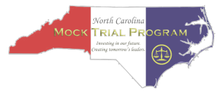
TO: All Teachers, Attorneys or Coaches FROM: Emme McManus
NCMTP Program Administrator

RE: North Carolina Mock Trial – Release Forms

Each participant in any NCMTP Mock Trial activity (mock trial or courtroom artist competition) shall be required to submit a signed Release form. Two forms are attached: one for participants under the age of 18 and the other for those participants over age 18. Please make sufficient copies and return the signed forms by the indicated deadline. Thank you.
PERMISSION FOR PARTICIPATION AND RELEASE OF ALL LIABILITY
(“Release”) Due by Thursday, Jan 4, 2024

I, the undersigned, am the lawful guardian of ___________________________ (please print full name of participant < age 18 ), a student at _____________________________(print full name of school) located in ___________________________(city), North Carolina.
I am informed that the North Carolina Mock Trial Program (“NCMTP”), a 501(c)(3) non-profit, sponsors certain activities which include, but are not limited to, regional and state mock trial competitions to be held in the State of North Carolina, summer camps, and scholarship competitions. In addition, the NCMTP provides sponsorship to the team winning the N.C. statewide competition so that it might attend a national competition. This Release extends to all activities of the NCMTP including, but not limited to, the above-named child’s preparation for, travel to and from, and participation in any of the aforementioned activities. By my signature below, I agree to the participation of the above-named child in any activity which is any way connected with the NCMTP, understanding that the above-named child is at a higher risk of contracting Covid-19 in larger gatherings.

IN CONSIDERATION of my voluntary participation in the activities of the NCMTP, I, for myself, my heirs, executors, administrators, successors and assigns, hereby agree to release the NCMTP from any and all liability whatsoever arising from my participation in any activity of the NCMTP and further agree to release, indemnify and hold harmless, the NCMTP from any and all claims, damages, expenses, or costs whatsoever arising from my participation in any activity of the NCMTP.

As used in this Release, the term “NCMTP” refers to the 501(c)(3) organization, any member of the NCMTP Board of Directors or Executive Committee, any paid NCMTP employees, and persons assisting the NCMTP for any activity in any way connected with the NCMTP.

By my signature below, I also agree, on behalf of said child, that any scholarship essay or other essay (or courtroom artist submission) prepared by such child and submitted to the NCMTP shall become the sole and exclusive property of the NCMTP and may be used by the NCMTP in any manner it deems appropriate.

I further agree, on behalf of said child, to give full rights to the NCMTP and its agents to freely use, reproduce, distribute, broadcast or transmit via any media (including the Internet and social network) said child’s image or video recorded in connection with the abovementioned NCMTP activities for purposes of education or publicity. This permission extends to the granting by the NCMTP of rights to third parties or news media for the use of those images in perpetuity. I acknowledge that I have read this Release in its entirety and that I fully understand and agree to all its terms.

Dated: _____________________ ____________________________________
Signature of Lawful Guardian

Return to: NCMTP, c/o Program Administrator Emme McManus
P.O. Box 17103, Chapel Hill, NC 27516 | emme@ncmocktrial.org
PERMISSION FOR PARTICIPATION AND RELEASE OF ALL
LIABILITY (“Release”) Due by Thursday, Jan 4, 2024

I, ______________________________(please print full name) the undersigned, am 18 years of age or older. I am a student at ___________________________ (print full name of school) located in _________________ (city), North Carolina.

I am informed that the North Carolina Mock Trial Program (“NCMTP”), a 501(c)(3) non-profit, sponsors certain activities which include, but are not limited to, regional and state mock trial competitions to be held in the State of North Carolina, summer camps, and scholarship competitions. In addition, the NCMTP provides sponsorship to the team winning the N.C. statewide competition so that it might attend a national competition. This Release extends to all activities of the NCMTP including, but not limited to, my preparation for, travel to and from, and participation in any of the aforementioned activities, understanding that I am at a higher risk of contracting
Covid-19 in larger gatherings.

IN CONSIDERATION of my voluntary participation in the activities of the NCMTP, I, for myself, my heirs, executors, administrators, successors and assigns, hereby agree to release the NCMTP from any and all liability whatsoever arising from my participation in any activity of the NCMTP and further agree to release, indemnify and hold harmless, the NCMTP from any and all claims, damages, expenses, or costs whatsoever arising from my participation in any activity of the NCMTP.

As used in this Release, the term “NCMTP” refers to the 501(c)(3) organization, any member of the NCMTP Board of Directors or Executive Committee, any paid NCMTP employees, and persons assisting the NCMTP for any activity in any way connected with the NCMTP.

By my signature below, I also agree that any scholarship essay or other essay (or courtroom artist submission) prepared by me and submitted to the NCMTP shall become the sole and exclusive property of the NCMTP and may be used by the NCMTP in any manner it deems appropriate.

I further agree to give full rights to the NCMTP and its agents to freely use, reproduce, distribute, broadcast or transmit via any media (including the Internet and social network) my image or video recorded in connection with the abovementioned NCMTP activities for purposes of education or publicity. This permission extends to the granting by the NCMTP of rights to third parties or news media for the use of those images in perpetuity. I acknowledge that I have read this Release in its entirety and that I fully understand and agree to all its terms.

Dated: ______________ _______________________________________
Signature (IF AGE 18 OR OLDER)

Return to: NCMTP, c/o Program Coordinator, Emme McManus
P.O. Box 17103, Chapel Hill, NC 27516 | emme@ncmocktrial.org

North Carolina Mock Trial Program Code of Ethics Form

(this version is for instructional purposes only; teacher coaches are asked to visit ncmocktrial.org to sign and submit this form electronically)

I, __________________________(print name), teacher-sponsor of the _______________________
_______________________________High School Mock Trial team(s), do hereby affirm that I have provided a copy and explained the following points to the team participants (students, assistant teacher coaches, and attorney advisors) and have asked them to communicate the same to any family or friends who will be observers at the Mock Trial competition:
- The Rules of the Competition and this Code of Ethical Conduct will be followed by all participants in the NCAJ High School Mock Trial Competition. We understand that a violation of the Code by any one of the members of this team may result in sanctions including, but not limited to, the team’s immediate eviction from the competition, suspension from competing in future competitions, and forfeiture of all fees and awards (if applicable).
- Team members, coaches and other observers promise to participate in all events associated with the NCAJ High School Mock Trial Competition with the highest standards of professionalism, both inside and outside the courtroom. All participants and observers promise to show respect for their fellow team members, opponents, coaches, judging panel volunteers, competition volunteers, competition staff, and courthouse personnel.
- Displays of bad sportsmanship at any time during the competition are prohibited. Whether winning or losing, team members, coaches and all other participants are expected to be gracious and supportive of other teams. Coaches will lead by example.
- No team member, coach or other observer associated with the team signing this Code is allowed to enter any courtroom in which their team is not competing (no “scouting”).
- NO communication may take place between team members and coaches/observers during trial. It is imperative that all teams and observers avoid any appearance of impropriety, both during in-person or online competition (if applicable).
- Teams will respect their surroundings, follow all published courthouse regulations, use appropriate receptacles for all trash, leave restrooms and all other court and common areas in good order, and will otherwise behave as young professionals.
- The use of alcohol, drugs and weapons is forbidden in course of the competition, both at all competition sites and all mock trial sponsored events.
BY MY SIGNATURE, I AFFIRM THAT WE, THE MOCK TRIAL TEAM(S) OF ___________ _____________________________ HIGH SCHOOL, DO HEREBY ACKNOWLEDGE THE ABOVE CODE OF ETHICS AND CODE OF CONDUCT, AND AGREE TO ABIDE BY THEM IN BOTH LETTER AND SPIRIT.
Signed: ____________________________________________
Dated: _______________________
“M. Gordon Widenhouse Jr. Award” 2023-2024 Scholarship Application
The “M. Gordon Widenhouse Jr. Award for Inspirational Team Leadership” was established to honor the energy and commitment of the High School Mock Trial Competition's first program chairperson. The award’s recipient will not necessarily be a star witness or attorney, but he or she will be the person who held the team together throughout practices and competitions. This scholarship is only open to seniors in high school.
Team advisors should nominate one student per team. Nominated students must submit an: 1) essay describing his or her mock trial experience, and 2) letter of recommendation from a team advisor (teacher or attorney). Recommendations should focus on the student’s leadership abilities and contributions to his or her mock trial team.
An unattached $1,000.00 scholarship will be awarded to one North Carolina senior.

Print:
Student’s Full Name _____________________________________________________________

Date of Birth ____________ School ________________________________________________

Email Address ______________________________________________________

Phone number __________________________________

Note: The student’s email address and phone are required for notification purposes only.

Applicants should complete this form and attach a 1 to 2 page typed essay addressing the following question: “What have you learned from the mock trial experience? Please address the program’s impact on your leadership abilities.” The letter of recommendation can be sent separately.
Submit this application, essay and letters of recommendation to emme@ncmocktrial.org or mail to:
North Carolina Mock Trial Program, State Office Attn: Program Administrator Emme McManus
P.O. Box 17103, Chapel Hill, NC 27516
All materials must be received by 5 pm on February 14, 2024

Timekeeper/Bailiff Duties and Script
Both teams will provide a timekeeper for trial, so each team should bring and use 2 stopwatches. Both timekeepers will be seated in the jury box during the trial; please choose seats that will not interfere with or disturb the scoring jurors.
The Prosecution/Plaintiff timekeeper will also serve as bailiff, calling court to order and swearing in the witnesses if the Presiding Judge does not do so.

To open Court, Bailiff will stand and say:
“All rise. The U.S. District Court for the Mock District of Utopia is now in session. The Honorable Judge presiding.” All participants and observers remain standing until the judge is seated. Then say, “Be seated.”

Bailiff should swear in all witnesses at the judge’s request:
Witnesses should be sworn in at the beginning of the trial. If the judge asks you to swear in the witnesses, have them stand and raise their right hands.
“Please stand and raise your right hand. Do you promise that the testimony you are about to give will faithfully and truthfully conform to the facts and rules of the mock trial competition?” When they respond, “I do,” say, “You may return to your seats.” You have been sworn in.

Exhibits:
All exhibits are pre-numbered, and should be left with the Presiding Judge after being entered/used.

Both timekeepers: Keep time and know timekeeping guidelines: You must each have 2 stopwatches to enforce time. Time does not stop for the introduction of physical evidence (exhibits). Time does stop for other interruptions in the presentation. Do not count time when witnesses are sworn in, witnesses walk to/from the stand, attorneys make objections, or the judge rules on objections.
You will both be provided with large time cards marked with the appropriate time limits. (E.g., Direct Examination cards will read: “5:00”, “8:00”, “10:00”, “12:00”, “15:00”, “16:00”, “17:00”, “18:00”, “19:00”, “19:20”, “19:40”, “20:00/Stop.”) Show these cards to the jury panel and to the judge at the appropriate times.

Bailiff only: Call Court recess for jury deliberation:
When motioned to do so by the judge, say: “All rise.” When the judge has left the bench say, “Court is in recess.”

When the Court returns from recess:
TIME LIMITS
When the judge and jury reenter the courtroom, stand and say “All rise.” All remain standing until the judge says “Be seated.”

Close the Court (after the oral critique is finished):
When motioned to do so by the judge, say: “All rise.” When the judge has left the
bench, say, “Court is adjourned.” **Adjust to reflect the listed venue in the case materials, whether it be Utopia, New Caesarea, North Carolina, or some other locale.

TIME LIMITS
- Opening Statement (5 minutes per side)
- Direct and Redirect (optional) Examination (20 minutes per side)
- Cross and Re-cross (optional) Examination (18 minutes per side)
- Closing Argument (5 minutes per side)
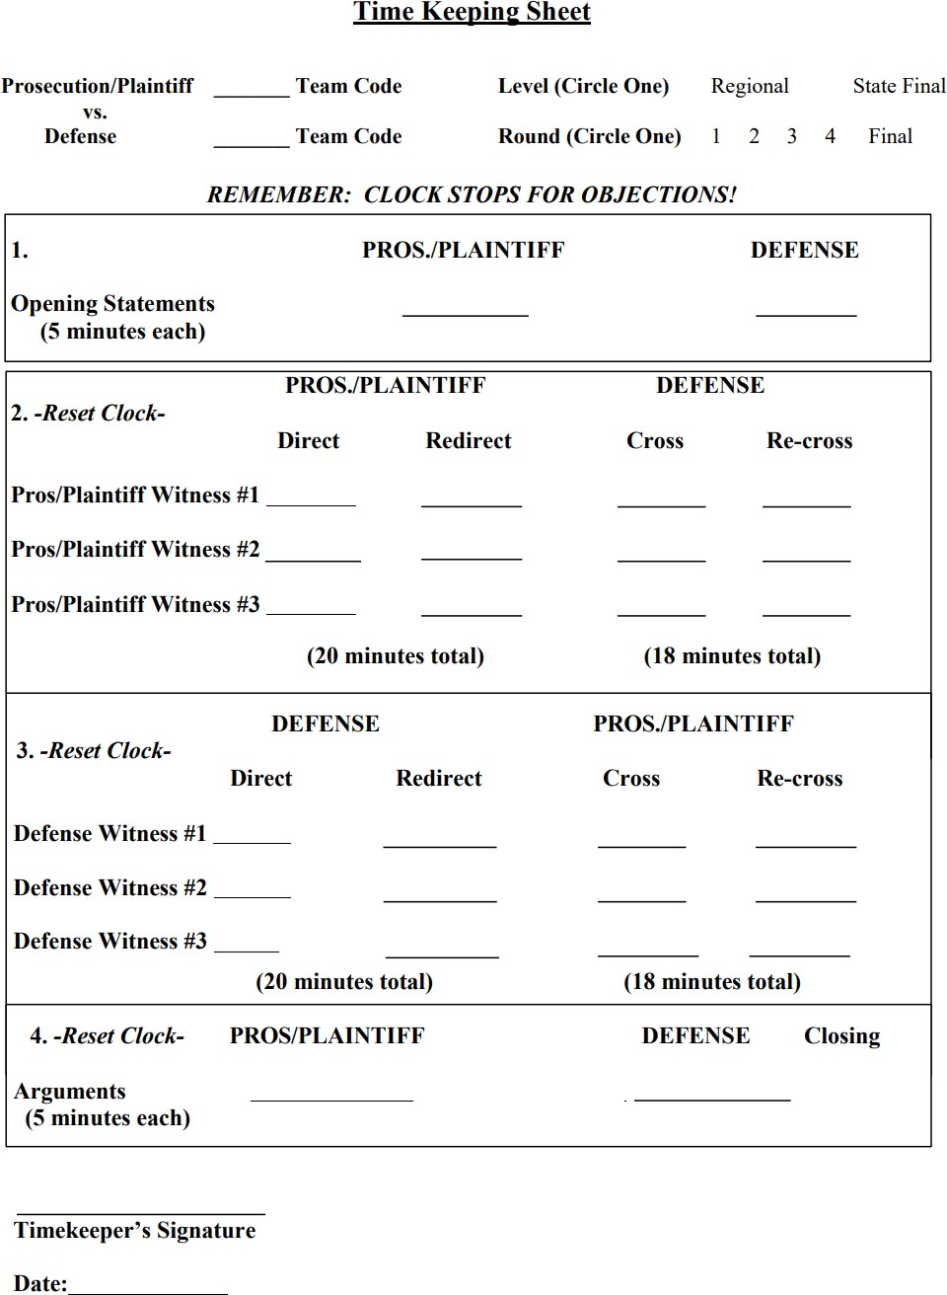

TIMECARD GUIDELINES
For Direct Examination
When your stopwatch says | Hold up the timecard that says
5:00 | 5:00
8:00 | 8:00
10:00 | 10:00
12:00 | 12:00
15:00 | 15:00
16:00 | 16:00
17:00 | 17:00
18:00 | 18:00
19:00 | 19:00
19:20 | 19:20
19:40 | 19:40
20:00 | 20:00/STOP

For Cross Examination
When your stopwatch says | Hold up the timecard that says
3:00 | 3:00
6:00 | 6:00
8:00 | 8:00
10:00 | 10:00
13:00 | 13:00
14:00 | 14:00
15:00 | 15:00
16:00 | 16:00
17:00 | 17:00
17:20 | 17:20
17:40 | 17:40
18:00 | 18:00/STOP

For Opening Statements & Closing Arguments
Opening |  | Closing
Stopwatch | Timecard | Stopwatch | Timecard
1:00 | 1:00 | 1:00 | 1:00
2:00 | 2:00 | 2:00 | 2:00
3:00 | 3:00 | 3:00 | 3:00
4:00 | 4:00 | 4:00 | 4:00
4:20 | 4:20 | 4:20 | 4:20
4:40 | 4:40 | 4:40 | 4:40
5:00 | 5:00/STOP | 5:00 | 5:00/STOP

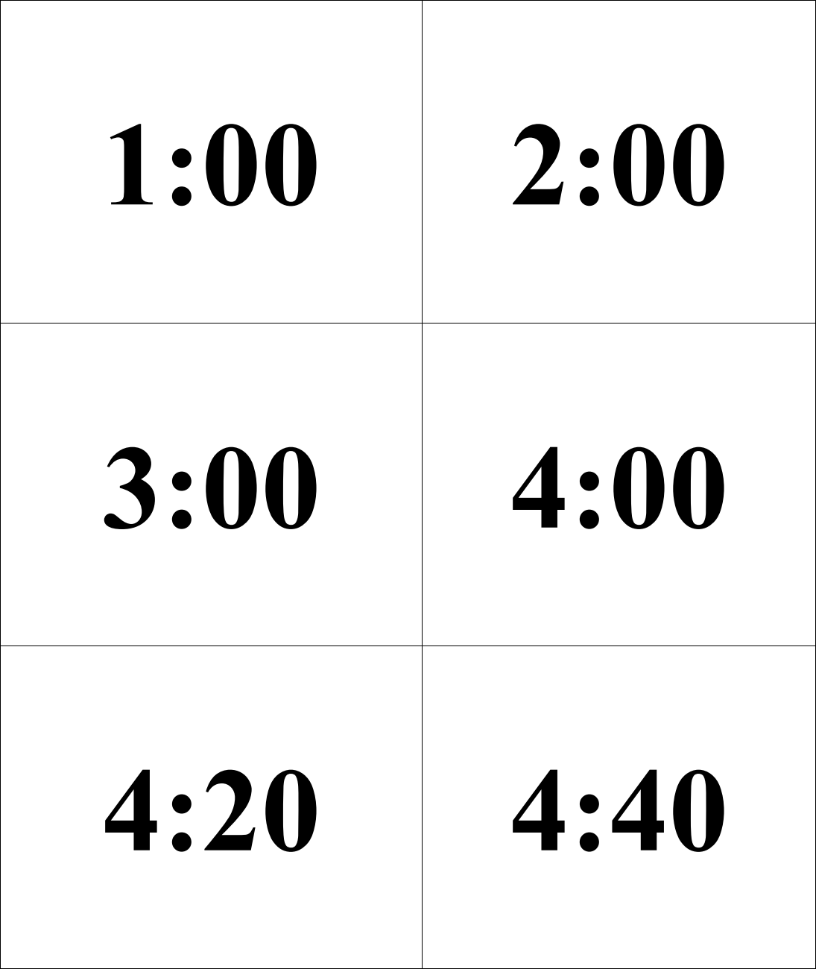
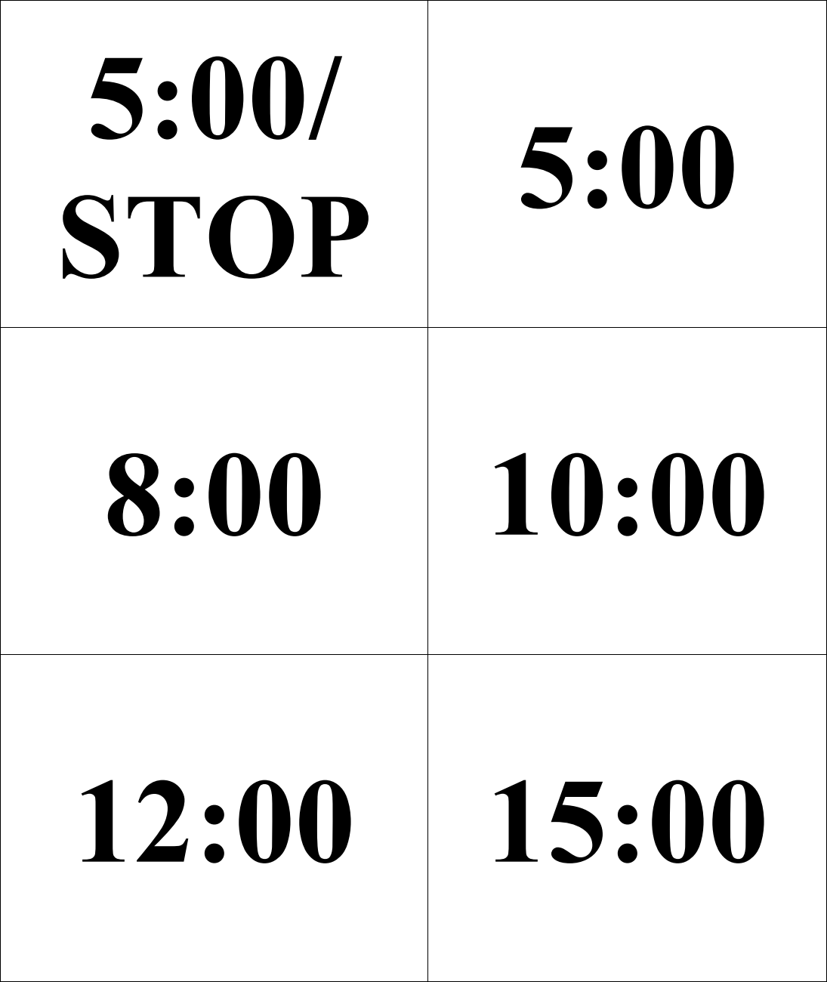
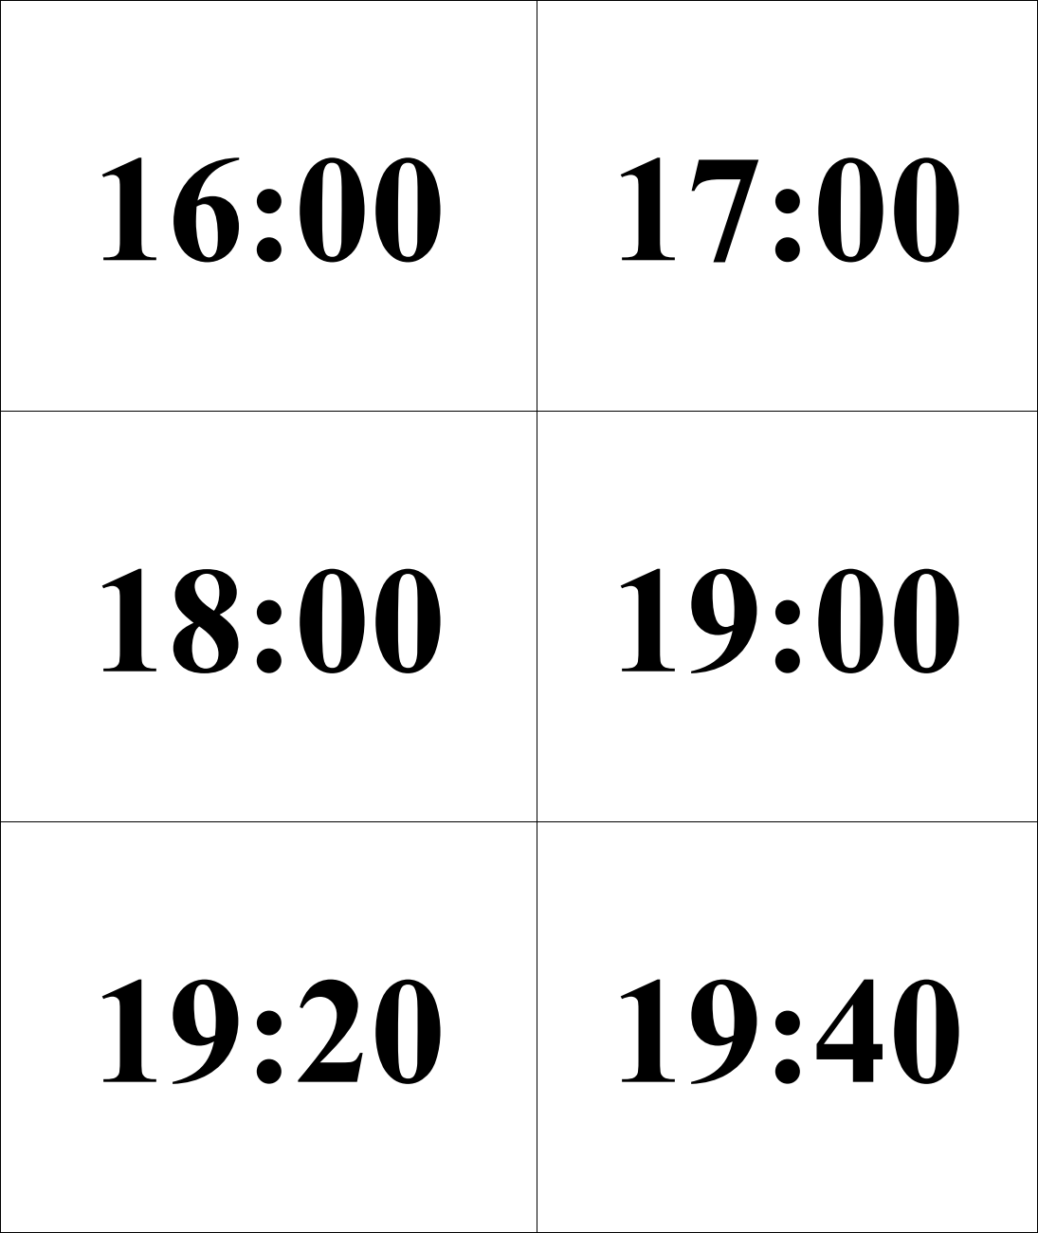
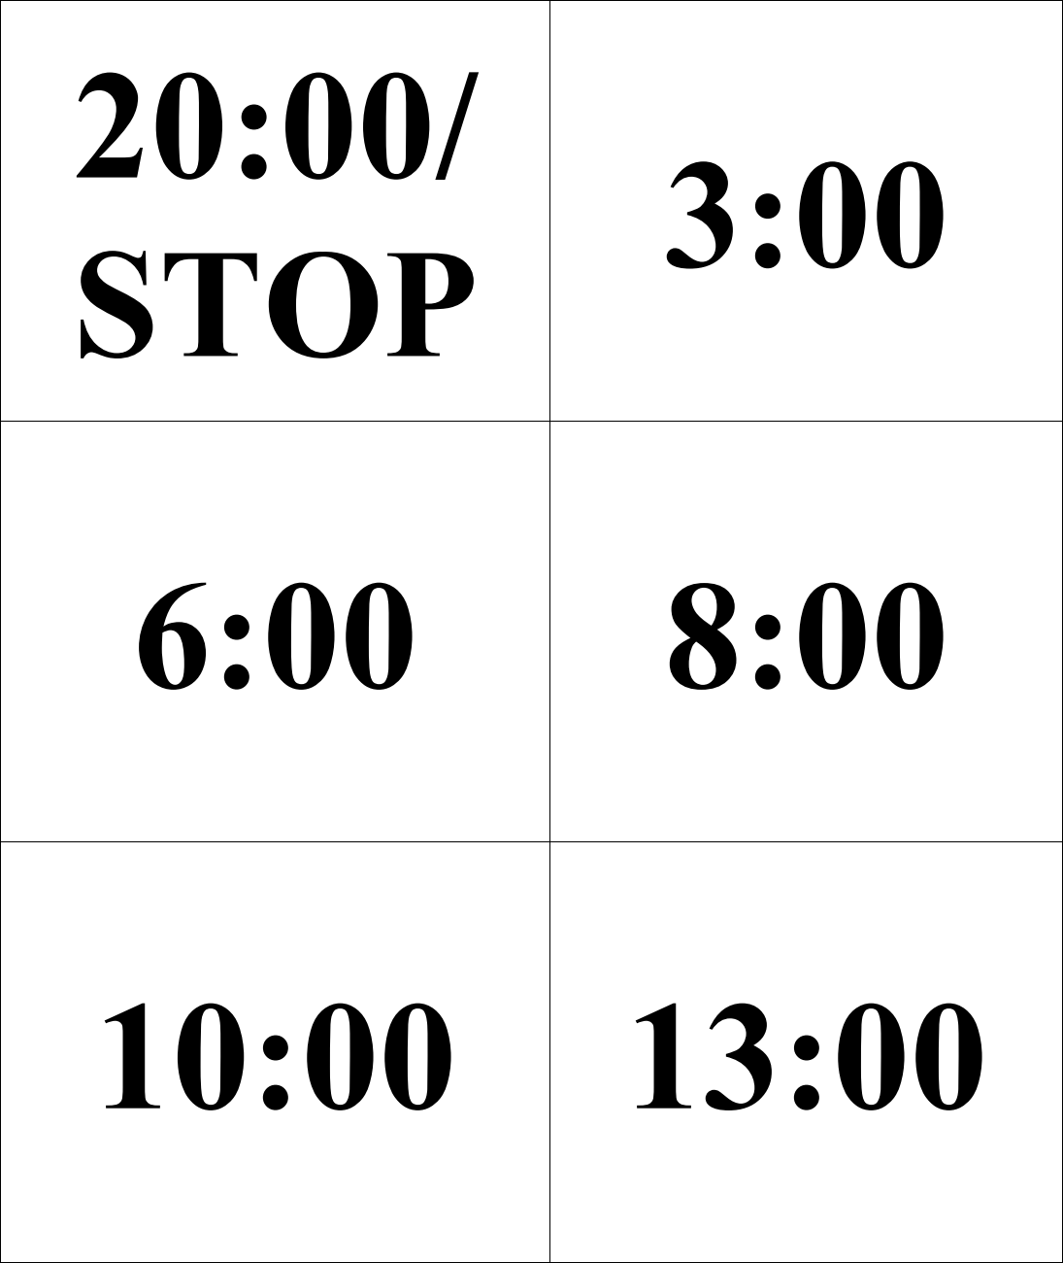
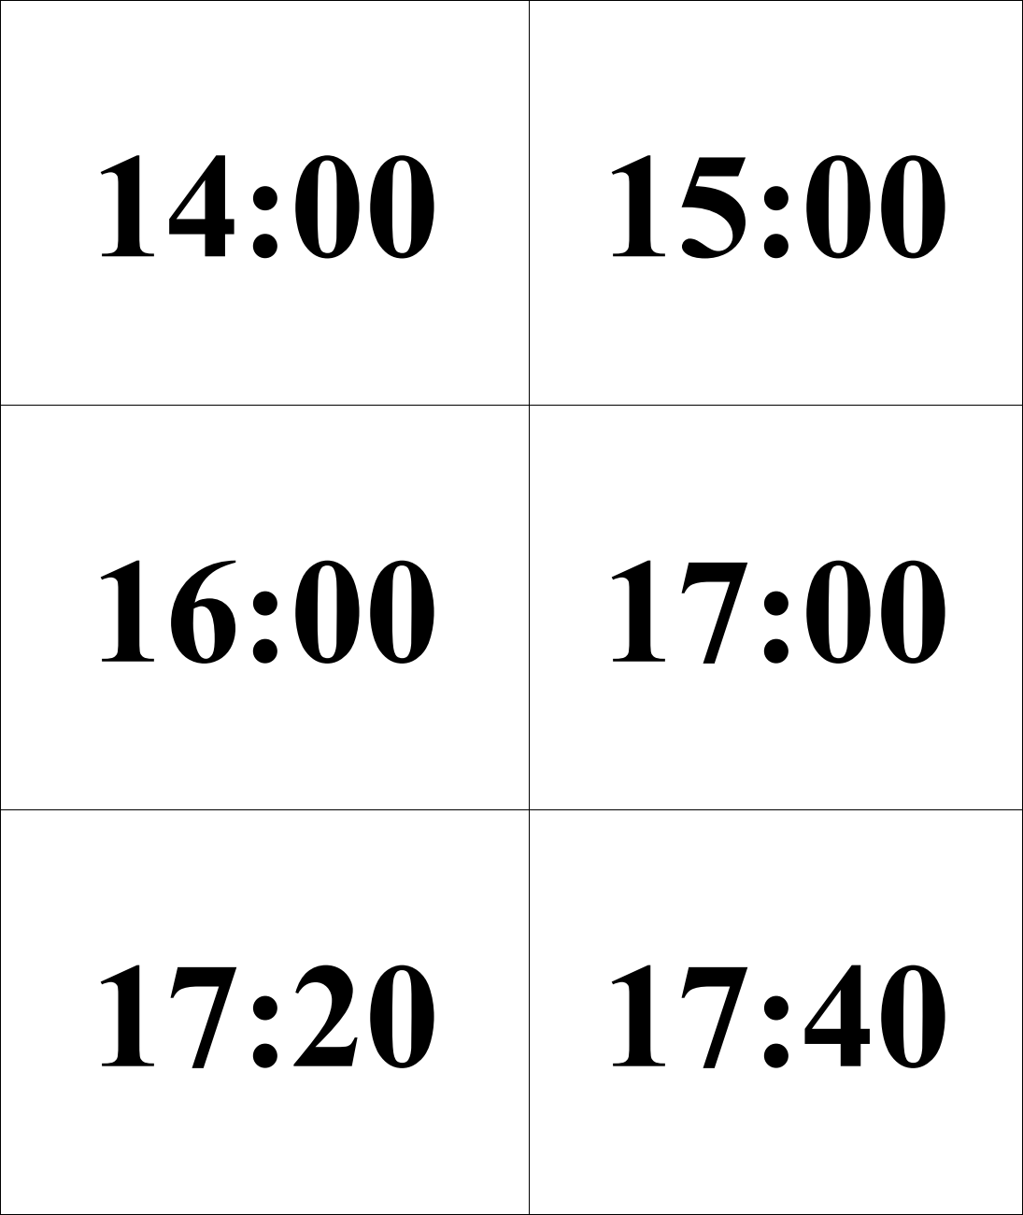

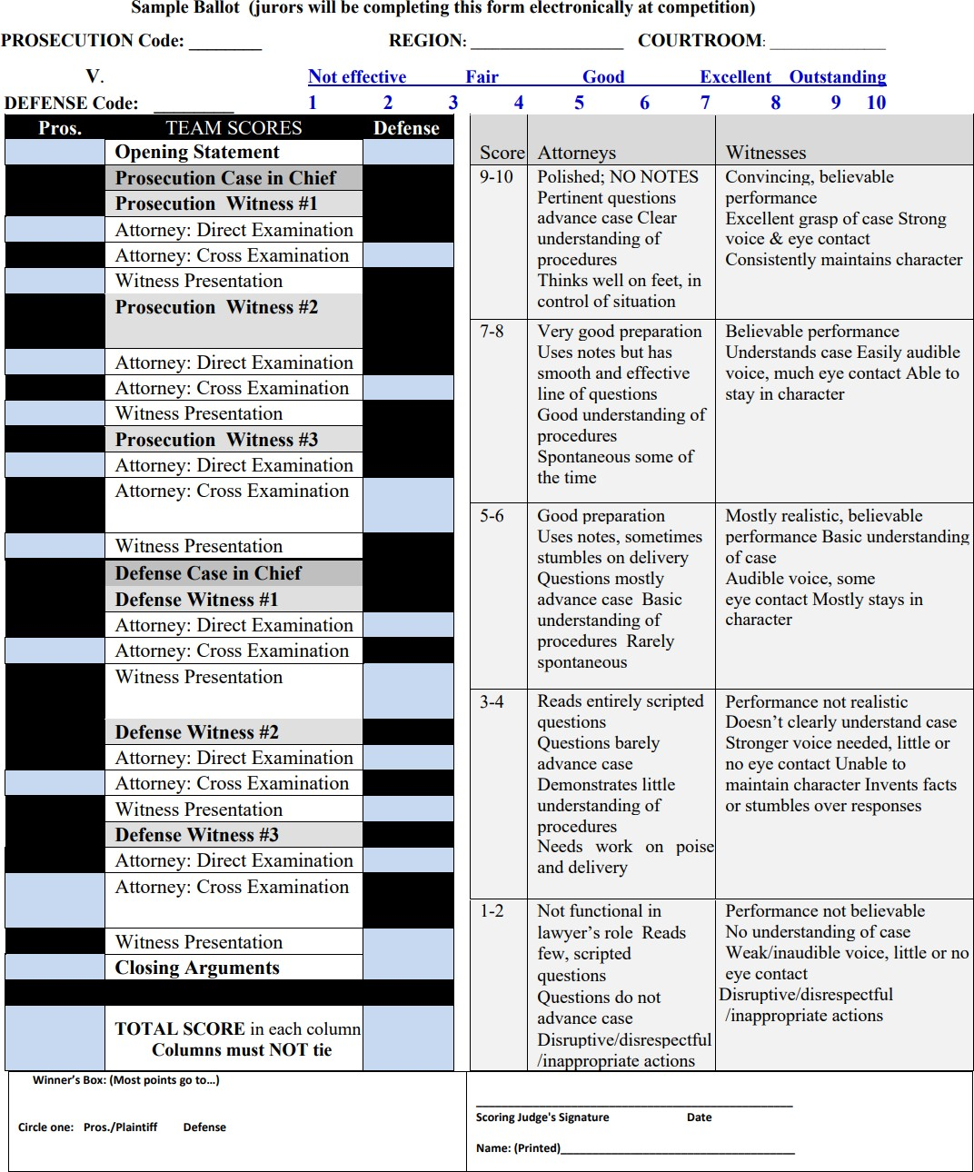
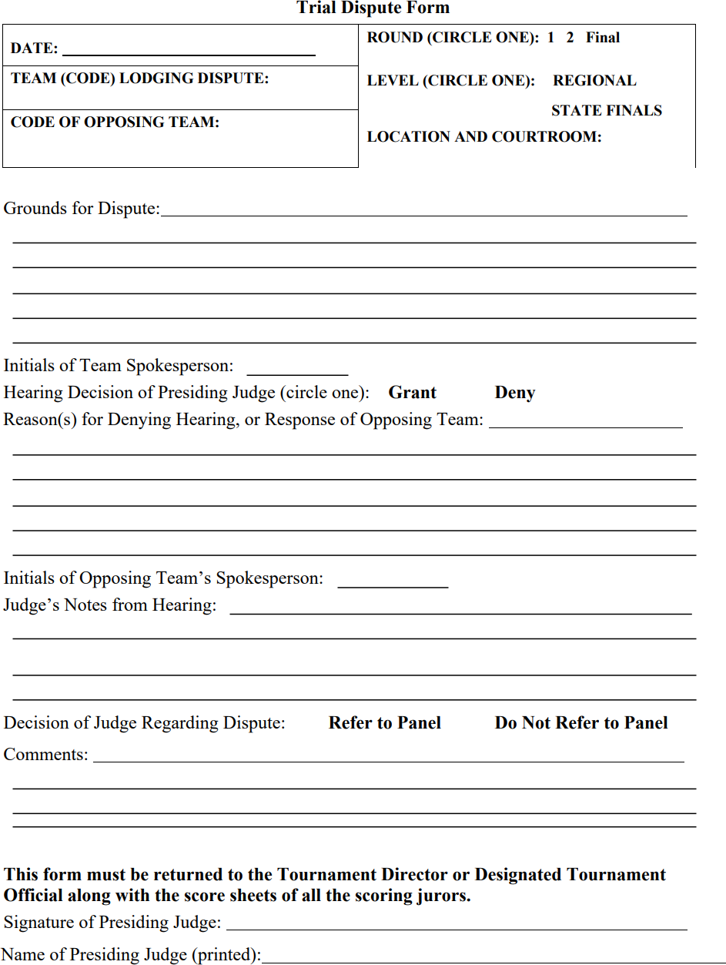

Steps in a Mock Trial

The Opening of the Court
As the judge and jurors enter, the bailiff (timekeeper for the Prosecution/Plaintiff) should call the court to order (“All rise” “The U.S. District Court for the Mock District of Utopia is now in session”). All the participants should remain standing until the judge is seated.

The judge will then ask the attorneys for each side if they are ready.
Each team member will introduce themselves and identify the role they will play. The team leader should introduce the courtroom artist if applicable. No time is kept during this introductory phase of the trial.

Opening Statement
  - Prosecution (in criminal cases)/Plaintiff (in civil cases)
The prosecutor in a criminal case (or plaintiff's attorney in a civil case) summarizes the evidence that will be presented to prove the case, being careful not to make any arguments or assert that the jury will hear evidence which may not be admitted.
  - Defendant (in criminal or civil case)
The defendant's attorney summarizes the evidence that will be presented to rebut the case the prosecution has made, being careful not to make any arguments or assert that the jury will hear evidence which may not be admitted.

Direct Examination by Prosecution/Plaintiff’s Attorneys
The prosecutors (or plaintiff's attorneys) conduct the direct examination of their own witnesses. At this time, testimony and other evidence to prove the prosecution's (plaintiff's) case will be presented. The purpose of direct examination is to allow the witness to state the facts in support of the case.

Note: The attorneys for both sides, on both direct and cross-examination, should remember that their only function is to ask questions; attorneys themselves may not testify or give evidence, and they must avoid phrasing questions in a way that might violate this rule.

Cross-Examination by the Defendant's Attorneys

After the attorneys for the prosecution (plaintiff) have completed questioning each witness, the judge then allows the other party (i.e., defense attorney) to cross-examine the witness. The cross examiner seeks to clarify or cast doubt upon the testimony of opposing witnesses. Inconsistency
in stories, bias, and other damaging facts may be pointed out to the jury and the judge through cross examination. Leading questions should be used on cross-examination (but may not be used on direct examination).

Direct Examination by the Defendant's Attorneys

After all the prosecution's (plaintiff's) witnesses have been examined by both sides, the prosecution/plaintiff will rest its case. Next, the defense will conduct the direct examination of its own witnesses.

Cross-examination by the Prosecution/Plaintiff's attorneys.

The prosecution’s/plaintiff’s attorneys will cross-examine each of the defense witnesses.

Closing Arguments (Attorneys)

  - Prosecution (Plaintiff)

The closing argument is a review of the evidence presented. It should indicate how the evidence has satisfied the elements of the charge or claim, describe the burden of proof, point out the law applicable to the case, and ask for a favorable verdict.

  - Defendant

The closing argument for the defense is essentially the same format as for the prosecution. Counsel for the defense reviews the evidence as presented, indicates how the evidence does not satisfy the elements of the charge or claim, stresses the facts favorable to the defense, and asks for a verdict favorable to the defense.

COURTROOM SETTING NOT APPLICABLE IN ONLINE COMPETITION. FOR EDUCATIONAL PURPOSES ONLY

A typical courtroom setting is diagrammed below. Team and attorney advisors are advised to arrange at least one team practice at a courthouse to familiarize students with the setting.
